

Movie Database Project

Rapid Application Development

The MisSprints Catherine Burns, Jai Ananda & Ben Royans

Contents

Sprint One 1

Source Control Screenshot 1

Project Management Plan 1

Analysis Report 2

Business Rules for Software Development 2

Introduction 2

Project Scope 2

Glossary Terms 2

Business Rules 3

Movie Website Navigation Chart 3

CITE Managed Services Quality Assurance 4

Organisational Roles 4

CITE Coding Standards 4

CITE Quality Assurance 5

Quality Objective 5

Quality Objective 5

Testing Goals 5

Acme Entertainment Pty Ltd Development Requirements 6

Adaptive Design 7

Description 7

Advantages 7

Disadvantages 7

Responsive Design 7

Description 7

Advantages 7

Disadvantages 8

Project Selection 8

References 8

Test Plan 10

1.0 Sprint One 11

Introduction 11

Rapid Application Development (RAD) and Workflow Diagram 11

Scrum Testing Strategy 11

Scope 12

Out of Scope 12

Quality Objective 12

Quality Objective 12

Testing Goals 12

Roles and responsibilities of each team member 13

Scrum Master: Catherine Burns 13

Developement Team : Benjamin Royans , Jai Ananda 13

Test Methodology 14

Overview 14

Bug Triage 14

Confirm new bugs 14

Prioritise confirmed bugs 14

Solve inconsistencies 14

Review stale/in-progress bugs 14

Review prioritised bugs 14

Suspension Criteria And Resumption Requirements 15

Suspension Criteria 15

Resumption Criteria 15

Test Completeness Check 15

Resource & Environment Needs 15

Testing Tools 15

Test Levels 16

Test Levels define the Types of Testing to be executed on the Application Under Test (AUT). 16

Constraints: 16

Test Environment 16

Intergration Testing 17

Consistency Validation Report 19

1.1 Sprint Two 20

Source Control Snapshot 20

Project Management Plan 20

Introduction 21

In Scope 21

Out of Scope 21

Quality Objective 21

Roles and Responsibilities 21

Business Requirements 22

Business Requirement Identification 22

Requirements Traceability Matrix 22

Test Cases 23

Test Case Results Table 23

Test Case Screenshots 24

Performance Report 38

Definition 38

Goal 38

Assumptions 38

Process Description 39

Data needs Analysis 39

Performance Extracts of Admin Page 42

Network Analytics 43

Memory Stats 44

Security Overview 44

Performance Extracts of Index Page 45

Network Analytics 46

Memory Stats 47

Security 47

Warnings/Error Logging 47

Software Review – Sprint Two 48

Requirements Overview 48

Current Requirements (05/06/2020) 48

Test Case 56

Test on current user input forms and web multi platform display (05/06/2020) 56

Updated Client Requirements 57

Updated Client Requirements 57

User interface Design mock up 58

User Subscribe Page 58

Admin Login Page 58

Admin Page – Main Dashboard 59

Movie Database Table 59

Subscriber List & Remove from Subscription page 60

Add Movie to Database Page 60

Business Requirements 61

Updated as of 06/06/2020 61

Requirements Traceability Matrix 61

Updated as of 06/06/2020 61

Test Cases 62

1.2 Sprint Three 64

Project Management Plan 64

Source Control Screenshot 65

Test Plan 66

In Scope 66

Out of Scope 66

Quality Objective 66

Roles and Responsibilities 66

Business Requirements 67

Business Requirement Identifcation 67

Requirements Traceability Matrix 67

Test Cases 68

Test Case Results Table 68

Test Case Screenshots 69

Performance Report 79

Optimization Report 86

Definition 86

Need for Optimization 86

Case Studies 86

Best practices 86

Performance Tuning steps followed 86

Performance Optimization Techniques followed 87

Previous Observations 88

Performance Extracts of Admin Page 88

Network Analytics 89

Memory Stats 90

Security Overview 90

Performance Extracts of Index Page – Initial Historical Observation 91

Network Analytics 92

Memory Stats 93

Security 93

Warnings/Error Logging 93

Current performance Extracts of Index Page – Under Shared memory 94

Current performance Extracts of Index Page – Under Unshared memory 98

1.3 Handover 99

Project Management Plan 99

Source Control Snapshot 100

Final Test Plan 101

In Scope 101

Out of Scope 101

Roles and Responsibilities 101

Scrum Master: 101

Developers 101

Business Requirements 102

Business Requirement Identifcation 102

Requirements Traceability Matrix 102

Test Cases 103

Test Case Results Table 103

Test Case Screenshots 105

# Sprint One

## Source Control Screenshot

Link: <https://github.com/RuggedRadius/ACME-Entertainment-Movie-Database>

Screenshot:

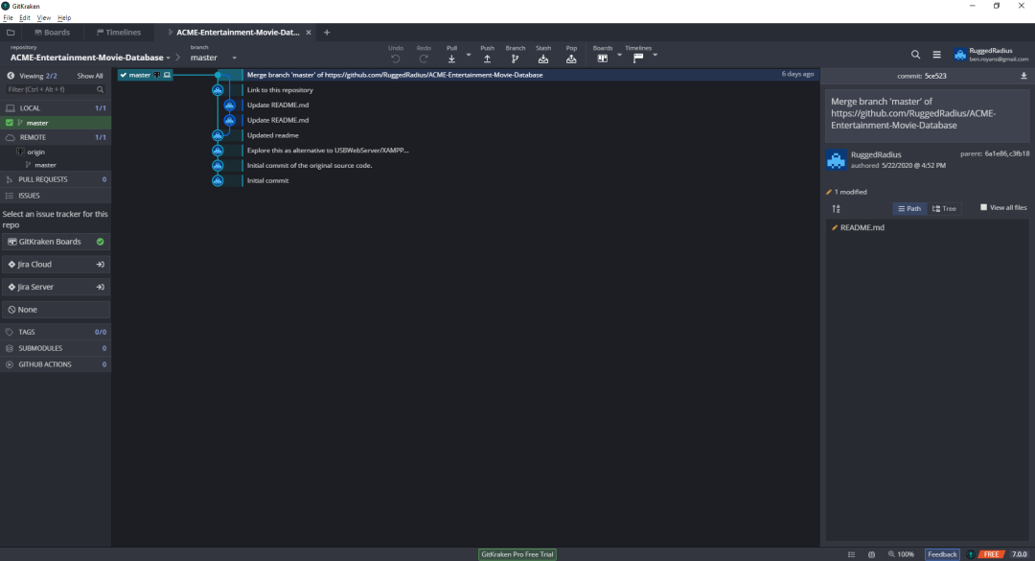

### Project Management Plan

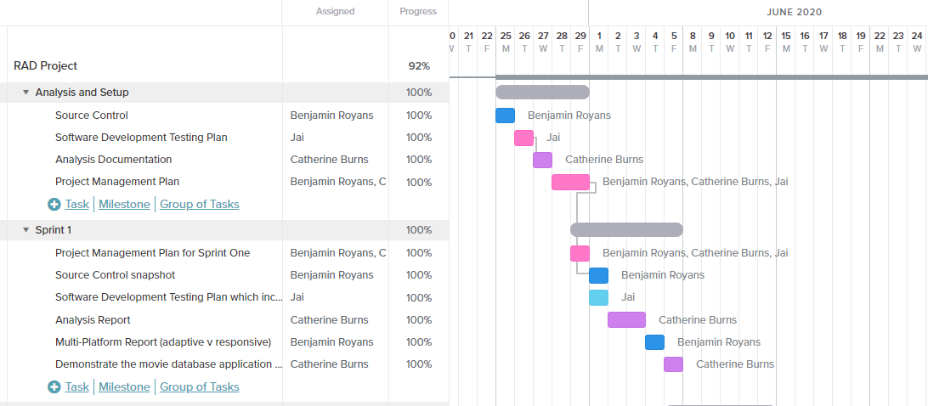

## Analysis Report

### Business Rules for Software Development

### Introduction

CITE Managed Services develops software for a range of clients and from time to time they will utilise external contractors when appropriate. CITE has sought to employ The MisSprints developers to implement a Movie Database for Acme Entertainment Pty Ltd. The directive is to adopt sprint workflow to develop each set of user requirements.

This project will be overlooked by Mr Andrew Samway, Product Owner and liaison Consultant for CITE Managed Services.

### Project Scope

The project that this documentation is for, is a movie database that allows users to search and view movies. Each movie will display the movie’s information that is fetched from the database. The movie database website to be able to display on all the major digital platforms.

### Glossary Terms

These are the following terms that may be used in the following documentation, any new terms will be added throughout the duration of the project.

Database – Stores all data and information needed for the application.

Software Development Lifecycle – a method in which the developing team follows to go step by step through the project’s life until completion.

Input- information that gets entered into the computer by the user.

Web Browser – a application that connects to the internet and displays websites.

Digital Platforms – these are devices that display digital items such as computers, mobiles, tablets.

### Business Rules

These are the following rules of how the product works and how the user interacts with it.

1. The website must work on different web browsers, eg Chrome, Firefox Microsoft Edge.
2. The website must be able to display correctly and smoothly on different device screens, such as tablet, mobile, desktop.
3. Input is needed to allow the user to search for a movie in the database.
4. If no input is entered, no movies will be displayed.
5. The user cannot search for multiple movies using more than one keyword.
6. The user cannot edit or change any movie details other than rating the movie.
7. The user must be able to favorite their movies and add to their list.

### Movie Website Navigation Chart

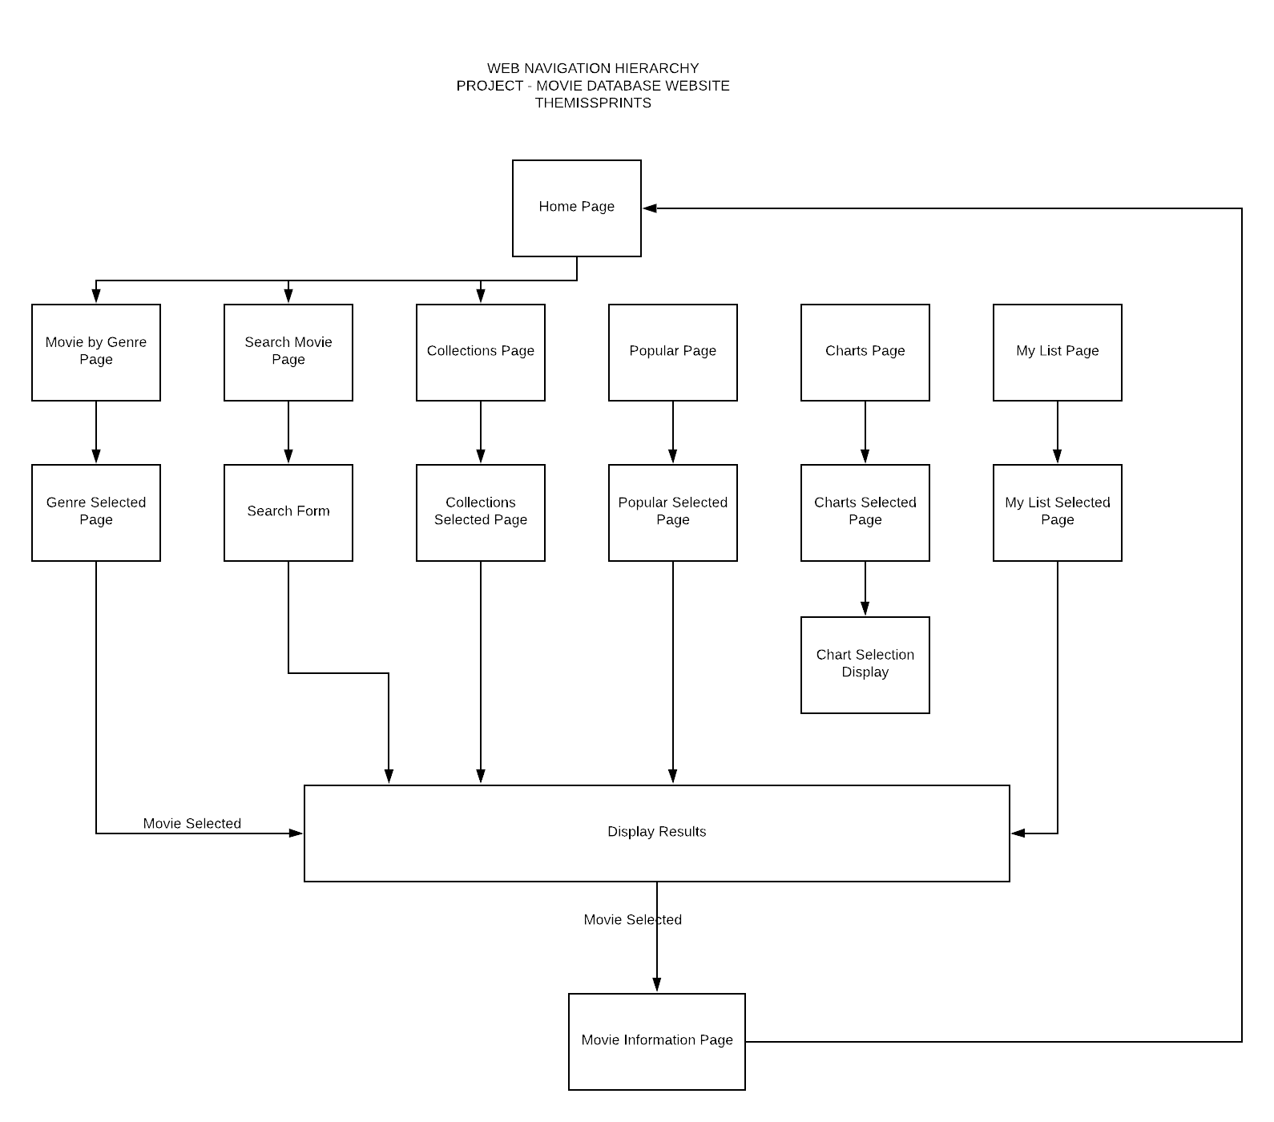

## CITE Managed Services Quality Assurance

### Organisational Roles

We, TheMisSprints are a small team of 3 that are working with CITE Managed Services.

**Scrum Master:** Catherine Burns

**Development Team:** Jai Ananda, Ben Royans

Detail description of the Roles and responsibilities of different team members like

Scrum Master is the facilitator of the Scrum- the lightweight framework of Agile framework. Scrum master act as coaches the team.

Test Manager is responsible for the test effort’s success by advocating, resource planning a management and resolution of the issues that impede testing. This encompasses the following:

* Negotiate purpose and deliverables of testing
* Planning and management of test resources
* Assessing testing progress
* Advocating the quality of testing by quantifying defects
* Advocate appropriate level of testability in the software development process

Developers is responsible for the following

* Creating and implementing the source code for new applications
* Testing and debugging the source code
* Evaluate applications and update with suitable modifications
* Develop technical handbook to represent design code
* Create digital software interface that entices the user into a seamless interaction between the client and the application

### CITE Coding Standards

Coding standards are collections of coding rules, guidelines, and best practices. To allow easy flow of coding styles, a guideline must be put in place for an organisation.

Common Aspects of CITE Coding Standard:

• Naming Conventions  
• File Naming and Organization  
• Formatting and Indentation  
• Comments and Documentation  
• Classes, Functions and Interfaces  
• Pointer and Reference Usage  
• Testing

All systems and projects will be covered by the following ISO standards.

ISO/IEC/IEEE 12207:2017 Systems and software engineering — Software life cycle processes

### CITE Quality Assurance

CITE Managed Services performs quality assurance throughout the entire software development lifecycle as regular quality testing is done at every stage of the way. CITE standards are to use a variety of test types to ensure the project enjoys in-depth quality assurance.

Some test styles we have included in this weeks Sprint 1 are;

* Integration Testing
* System Testing
* Acceptance Testing

### Quality Objective

**Reference:**

**ISO 9001:2005: International standard that specifies requirements for a quality management system (QMS)**

### Quality Objective

* To Establish protocl between the application, application design and development _ what are the expectations from the website
* Empower Quality Assurance to have the application development proritize between fixing old bugs and developing new features

### Testing Goals

* Ensure the Application Under Test (AUT) conforms to functional and non-functional requirements
* Ensure the AUT meets the quality specifications defined by the client
* Ratio of Testcases conducted to th eapplication requirements are >1. Hence requirements are to be known to the entire team written to testcases executed should be 1 or approaching close to 1
* Be informed that the quality gols are determined by the production management, developers, QA as a team
* Ratio of testcases
* Bugs/issues are identified and fixed before go live

## Acme Entertainment Pty Ltd Development Requirements

The requirements given by ACME Entertainment are;

1. Index page contains navigation bar, frequently top 10 searched from most frequently searched to lesser of the 10 and footer.
2. Index page includes logo.
3. Movies will be categorized by genre, collections or popular.
4. Popular movie titles will be numbered by most searched, in the Popular section page.
5. Search page will contain search fields for the movie title, genre, rating and year.
6. Search page will display search results and include how many search results.
7. Search page will allow user to select on result movie titles which will direct them to that selected movie’s information page.
8. Search form must allow user to search by any combination of search inputs, whether it is all search field inputs or part’s of.

For example;

Title, genre, rating and year

Title, genre and year

Genre and year

Genre

1. Movie information page will include the movie poster, trailer, rating and details.
2. Website must be able to adapt to multiple device screen sizes.
3. Users must be able to add any movie to their list.

## Adaptive Design

### Description

Adaptive design refers to the creation of websites that operate within static thresholds for display resolution, known as the viewing context. The viewing context of the target device is assessed and a set of stylings are applied accordingly to the elements of the web page.

### Advantages

The main advantage of adaptive design is the final presentation of the webpage’s display is much more predictable during development. This is due to the elements being sized according to a selected fixed layout, determined by the screen’s resolution.

Adaptive designs can be made applicable to older devices that do not support responsive designs.

### Disadvantages

Adaptive design is limited to the static definitions of resolutions defined by the developer. As the webpage is loaded, and the resolution is assessed, a pre-determined layout is selected appropriately. Adaptive design has limitations here bound by the definitions of the developer.

Once a webpage is loading, adaptive layout selection is no longer applied. For example, in modern devices where it is possible to scale the resolution of the web browser on screen, the webpage will not adapt its design to a modified screen resolution after the page has loaded.

## Responsive Design

### Description

Responsive web design refers to the creation of websites using dynamically sized elements that are responsive to their parent containers, and ultimately the display resolution.

### Advantages

Responsive design is extremely flexible in its rendering approach. The designs are fluid are able to display responsively to any viewing context, in contrast to adaptive design’s fixed layout approach.

Statistics show that more than half of the global internet traffic (52+%) is from a mobile device (Hosting Tribunal, 2020). As mobile devices continue to be produced in various shapes and sizes, responsive designs gain an advantage of dynamically adapting to these devices.

Responsive designs achieve higher site rankings by search engines like Google or Yahoo!, therefore leading to more web traffic.

Responsive designs can reduce the need, and therefore the cost of, developing a separate mobile-friendly version of the website.

### Disadvantages

Site navigation can become more challenging to keep consist with responsive designs. As the screen size decreases, so too do the elements portraying the navigation paths.

Responsive web designs can also take longer to load than adaptive designs. This is due to their relative nature where the elements are sized in relation to the size of the parent elements. Longer loading times can often leading to a bad browsing experience on the user’s behalf.

Older browsers, or older devices who are limited with software, may not be compatible with responsive designs and will therefore show incorrectly.

## Project Selection

For this project we have chosen a hybrid design incorporating both Responsive and Adaptive approaches in order to maximise the benefits of both approaches.

Responsive design will provide an overall better look and feel (user experience) to the finished product and result in a higher Search Engine Optimization ranking. The majority of elements will be designed to be responsively sized and placed.

However, to maintain a broad support of different screen resolutions certain structural elements will have to be altered in order to conserve a functional user interface across large changes in resolution. This is where adaptive design will apply appropriate page layouts and stylings to particular structural elements such as the navigation menu in order to prevent un-intended visual phenomena or inhibition of the user interface.

### References

Graham, G. (2015, November 17). *The Difference Between Responsive and Adaptive Design*. Retrieved from CSS-Tricks: https://css-tricks.com/the-difference-between-responsive-and-adaptive-design/

Hosting Tribunal. (2020, 05 29). *What Percentage of Internet Traffic Is Mobile in 2020?* Retrieved from Hosting Tribunal: https://hostingtribunal.com/blog/mobile-percentage-of-traffic/

Skyresoft. (2020, May 17). *Top 5 Advantages and disadvantages of Responsive Website design*. Retrieved from Skyresoft: http://www.skyresoft.com/blog/5-homepage-design-practices-to-improve-usability-and-ux/

Soegaard, M. (2019, June 24). *Adaptive vs. Responsive Design*. Retrieved from Interaction Design Foundation: https://www.interaction-design.org/literature/article/adaptive-vs-responsive-design

UXPin. (2020, May 29). *Responsive Design vs. Adaptive Design: What’s the Best Choice for Designers?* Retrieved from UXPin: https://www.uxpin.com/studio/blog/responsive-vs-adaptive-design-whats-best-choice-designers/

# Test Plan

|  |  |  |  |
| --- | --- | --- | --- |
| Version | Change Date | By | Description |
| 1.0 | 5/06/2020 | Jai Ananda | Created document for sprint 1 |
| 1.1 | 8/6/2020 | Ben Royans | Updated for sprint 2 |
| 1.2 | 17/06/2020 | Catherine Burns | Updated for sprint 3 |
| 1.3 | 30/06/2020 | Ben Royans | Updated for final handover |

## Sprint One

### Introduction

### Rapid Application Development (RAD) and Workflow Diagram

RAD is an effective software development standard. Under circumstances wher eth einitial requirements are not clear or where requiements changes frequently takes place during the development, RAD provides a systematic software system that has the ability to be automated.

Sufficient sotware testing is required when producing software application of high quality. Classical testing methods are not ideal for iterative development like RAD. Hence, there is a need for tailored testing method for this development standard.

Assumptions: To adopt a testing stratgey we shall assume that RAD is

|  |  |
| --- | --- |
| * Iterative – includes Sprints * Isevolutionary – continuous development of the application with improvements * Contains the familiar technical RAD language | * Library facilities and data retrieval capabilities * Implemented code is from a high level language * Support environment is sophisticated |

### Scrum Testing Strategy

The following tests are performed on the software to ensure the application stands up to the QA standards of CITE

|  |  |
| --- | --- |
| * Complexity check * Quality Testing * Performace Testing | * Usability Testing * Unit Testing |

### Scope

CITE Managed Services develops software for a range of clients and from time to time they will utilise external contractors when appropriate. CITE has sought to employ The MisSprints developers to implement a Movie Database for Acme Entertainment Pty Ltd. The directive is to adopt sprint workflow to develop each set of user requirements.

This project will be overlooked by Mr Will E Coyote, Product Owner and liaison Consultant for CITE Managed Services.

The developer team has an established Scrum Master who shall allocate work the team memembers that are wihtin the scope of the first sprint.

Features of the application:

* The SMT Movie Rental provides 2300 movies for renting to the customers
* The prototype is in a visual format with navigation hierarchy established
* The application can be navigated to search for a movie record using the Movie Name, Genre, Rating and year of release
* The application also gives information on Top 10 of most searched movies

### Out of Scope

1. Secure login
2. Authorization: In case of lost credentials, there is no secured way of accessing the customer file to reset the confidential password
3. Multimedia auto loading into the thumbnails
4. User reviews

### Quality Objective

**Reference: ISO 9001:2005: International standard that specifies requirements for a quality management system (QMS)**

### Quality Objective

* To Establish protocl between the application, application design and development _ what are the expectations from the website
* Empower Quality Assurance to have the application development proritize between fixing old bugs and developing new features

### Testing Goals

* Ensure the Application Under Test (AUT) conforms to functional and non-functional requirements
* Ensure the AUT meets the quality specifications defined by the client
* Ratio of Testcases conducted to th eapplication requirements are >1. Hence requirements are to be known to the entire team written to testcases executed should be 1 or approaching close to 1
* Be informed that the quality gols are determined by the production management, developers, QA as a team
* Ratio of testcases
* Bugs/issues are identified and fixed before go live

### Roles and responsibilities of each team member

### Scrum Master: Catherine Burns

## Developement Team : Benjamin Royans , Jai Ananda

Scrum Master is the facilitator of the Scrum- the lightweight framework of Agile framework. Scrum master act as coaches the team.

Test Manager is responsible for the test effort’s success by advocating, resource planning a management and resolution of the issues that impede testing. This encompasses the following:

* Negotiate purpose and deliverables of testing
* Planning and management of test resources
* Assessing testing progress
* Advocating the quality of testing by quantifying defects
* Advocate appropriate level of testability in the software development process
* Developers is responsible for the following
* Creating and implementing the source code for new applications
* Testing and debugging the source code
* Evaluate applications and update with suitable modifications
* Develop technical handbook to represent design code
* Create digital software interface that entices the user into a seamless interaction between the client and the application

### Test Methodology

### Overview

This project employs the Rapid Application Development (RAD) methodology. This means testing occurs within every iteration (sprint) of the software development cycle. As this project has been structured to carry out weekly sprints, the testing will also occur as frequently.

### Bug Triage

The goal of the triage is to provide framework and structure for the process of eliminating bugs or issues within the software as it is being developed.

### Confirm new bugs

Confirm the presence or absence of a newly reported bug. Attempt to re-create the bug in simulated conditions.

### Prioritise confirmed bugs

Prioritise all existing bugs based on their severity level. The chart below will provide a guide as how to classify bugs.

### Solve inconsistencies

Gather any further required information regarding an existing bug and improve understanding.

### Review stale/in-progress bugs

Review any bug fixes currently in production, prioritising those that have not any recent progression.

### Review prioritised bugs

Assess each individual bug, devising possible solutions and documenting any restrictions.

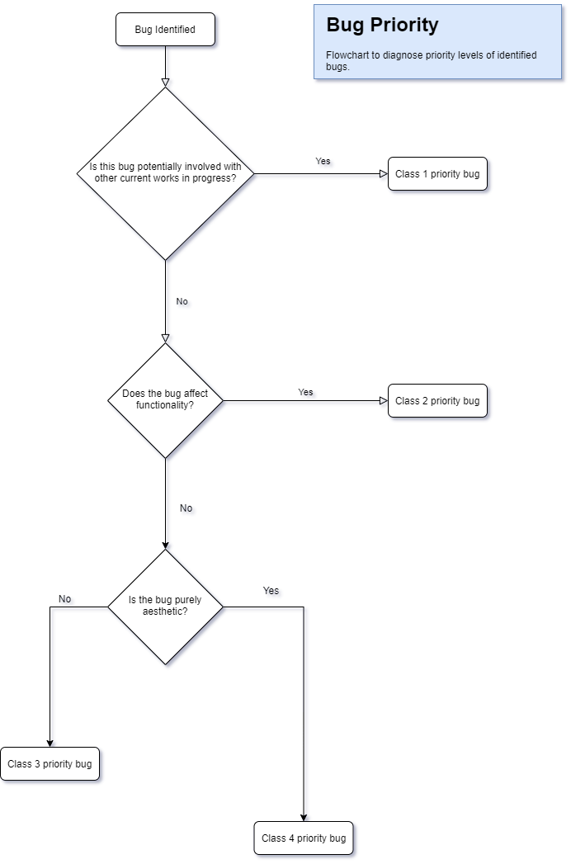

### Suspension Criteria And Resumption Requirements

The are the criteria for any disruption to the testing process and workflow.

### Suspension Criteria

Testing for a particular functoinality is to be suspended once a bug has been identified. Sub-sequential behaviour can not be deemed reliable for testing once bugged methods are used.

### Resumption Criteria

Testing for particular functionalities can be resumed once any identified bugs have been corrected by the developers.

### Test Completeness Check

Here you define the criterias that will deem your testing complete.

For instance, a few criteria to check Test Completeness would be

* 100% test coverage – Check in alignment with the requirements (frontend+backend)
* 100% code quality coverage
* User Acceptance testing coverahe – 100%
* All Manual & Automated Test cases executed
* All open bugs are fixed or will be fixed in next release

### Resource & Environment Needs

### Testing Tools

The following tools are required to test the software:

* A modern web browser (Such as Google Chrome or Mozilla Firefox)
* A text editor (Such as VS Code or Notepad++)
* A code cleaner (Such as PHPCodeSniffer)
* GitKraken GUI client (For access to Bugs/Issues board)

**Test Environment**

Below outlines the minimum hardware requirements that will be used to test the Application.

* [No minimum requirements]

The test environment is required to have one of the following operating systems installed:

1. Windows XP Service Pack 2 and above
2. Android Jellybean
3. Mac OS X

### Test Levels

### Test Levels define the Types of Testing to be executed on the Application Under Test (AUT).

1. Integration Testing
2. Testing by combining
3. Test for data flow
4. System Testing
5. Check for compliance as per requirements
6. Over interaction of components (Load, performance, reliability and security testing)
7. Optional check for non-functional requirements testing – on demand
8. Acceptance Testing
9. Check against requirement specification at deployment/delivery
10. Involve customer and other stockholders to run this testing process

### Constraints:

Time constraint : Delivery date for Sprint 1 presentation to the client scheduled for June 5th 2020

### Test Environment

It mentions the minimum hardware requirements that will be used to test the Application.

|  |  |
| --- | --- |
| Memory: 16GB | Processor: i7 10th Gen Intel 10950, 2.4GHz |

Following software’s are required in addition to client-specific software.

|  |  |
| --- | --- |
| 1. Windows 10, iOS 2. MS Office 3. VS Code 4. NotePad++ | 1. Google Chrome 2. MS Edge 3. Mozilla Firefox 4. MS Excel |

### Intergration Testing

|  |  |  |  |  |
| --- | --- | --- | --- | --- |
| Index | Use case | Steps | Test Results | Test Status |
|  | Create DB, Tables and data | 1. Navigate to the URL | DB, Table, Constraints and data created successfully |  |
|  | Dashboard | 1. Click on ‘Admin Login’ references 2. Click on ‘Genre’ references 3. Click on ‘collections’references 4. Click on ‘Search’ references 5. Click on ‘Top10’ references 6. Click on ‘Charts’ references 7. Click on ‘MyList’ references | 1. Navigates to admin.php successfully 2. Navigates to index.php successfully 3. Navigates to ‘connection.php successfully 4. Navigates to search.php successfully 5. Navigates to popular.php successfully 6. Navigates to charts.php successfully 7. Navigates to myList.php successfully | PASS |
|  | Search | Search by:   1. Movie title 2. Rating 3. Year 4. Genre | Results are found based on logical AND of the attributes if they are patterns of their respective fields or properties.  The search results are inserted into the table movie_searched if the corresponding movies are not in the table or else, the count or occurrences is incremented that correspond to the movies from the results.  A validation message is returned when no search criteria is entered. | PASS |
|  | Chart | Click on ‘Chart’ references | Top 10 most searched movies are plotted as a histogram along with the movie names and their occurrences.  This histogram is scaled and normalized and hence, it adjusts itself depending on if the occurrences are means or extemes.  The Histogram adjusts depending on the scaling factor that user may decide to vary using the given feature named ‘Scaling factor’ and hits the ‘Submit’ button.  By default, the scale would be set to the middle of the range. | PASS |
|  | Responsiveness Webs of Web design | Change the size of the browser | All the images on the web page are displayed properly on all the different devices and resolution.  Text and headings on the web page are properly aligned.  All Clickable links on the web page are readable and work as expected.  Scrolling of the web page works as expected.  Verify if there are input boxes and text areas to enter data then we need to make sure that the text entered is displayed properly on the web page and they are aligned as expected.  Image size, Font size and font type are consistent across all the web pages.  Verify if contents of the page are displayed consistent on all resolutions.  Verify the color changes after hover over the elements.  Verify the consistency of color combination on different resolutions.  Verify images, text, different controls are not going beyond the screen border.  Verify if there should not be any horizontal scrolling bar since everything should be fit according to the size of the screen.  Verify on rotating your mobile device, all the contents should be rotated and displayed as expected without any technical glitch.  Verify if the user able to click on clickable area.  Verify padding of elements on the edges.  Verify if enter text in input box are displayed as expected without any UI glitches. | PASS |

### Consistency Validation Report

|  |  |  |
| --- | --- | --- |
| PAGE | INPUT | RESPONSE |
| add.php | When all the inputs are empty | Inputs cannot be empty! |
| When one of the inputs is empty | Inputs cannot be empty! |
| When ID is duplicate | Add request denied! Duplicate value. |
| When invalid rectecprice is entered | Invalid rectec price. Please enter a valid rectec price.  The value must begin with numbers from 0 to 9.  Please enter a value that is accurate upto 2 decial places. |
| When invalid year is entered | Invalid year. Please enter a valid year. |
| When invalid ratings are entered | Invalid ratings entered. |
| When invalid status is entered | Invalid status entered. |
| When invalid genre is entered | Invalid genre entered. |
| search.php | When all the inputs are empty | Search criteria cannot be empty. |
| When one or more inputs are provided | Search results are based on logical “OR” operation between search criteria in the “WHERE” clause of the “SELECT” query |
| When partial search values are entered | Results returned would consist of the entered search criteria |
| When exact and full movie names are entered | The empty space values on the far ends of the search values are trimmed and the movie name if exists will be inserted into the table “movie_searched” in the database |
| modifyMovie.php | When one or more input boxes are empty | Inputs cannot be empty. |
| When ID is attempted to update | The ID value is Read Only and hence cannot be overwritten |
| When invalid rectecprice is entered | Invalid rectec price. Please enter a valid rectec price.  The value must begin with numbers from 0 to 9.  Please enter a value that is accurate upto 2 decial places. |
| When invalid year is entered | Invalid year. Please enter a valid year. |
| When invalid ratings are entered | Invalid ratings entered. |
| When invalid status is entered | Invalid status entered. |
| When invalid genre is entered | Invalid genre entered. |
| topRated.php | When there are no search results | No results found. |
| When search criteria are entered | The entered values are case converted to LOWER with adjustments so that the searched values are matched with the values existing in the database to display results |
| findall.php | When no values are existing in the movie database | No results found. |

# 1.1 Sprint Two

### Source Control Snapshot

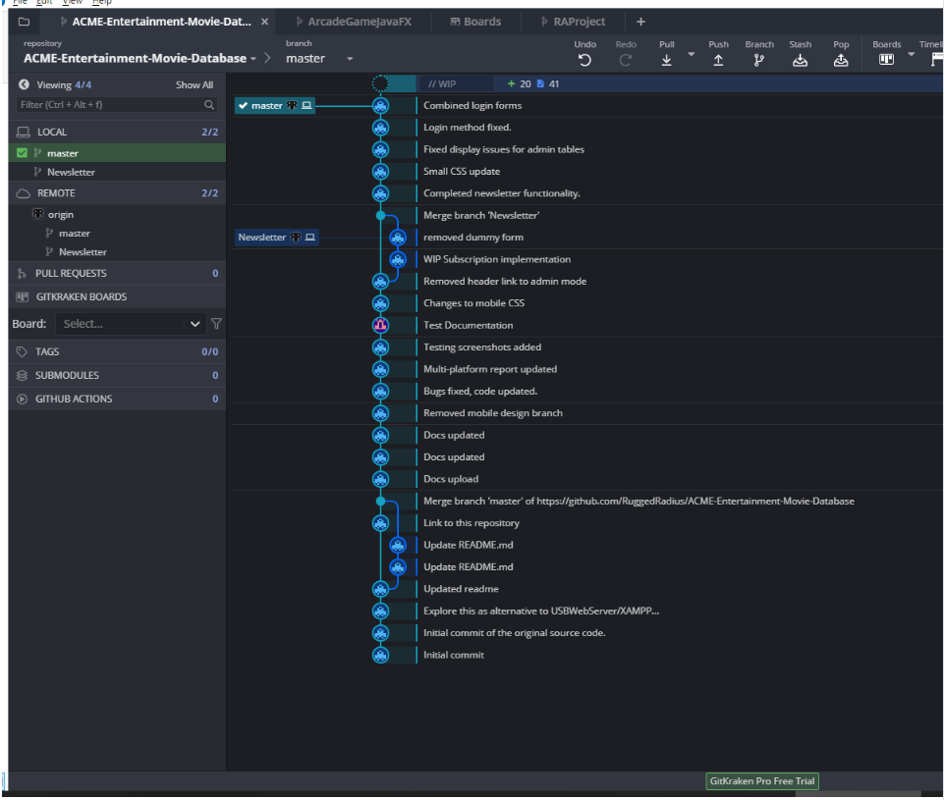

### Project Management Plan

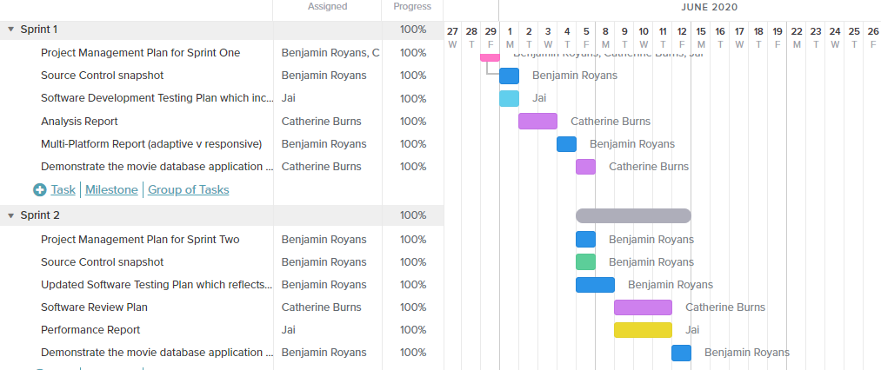

## Introduction

This document outlines the procedures, strategies and other details regarding the testing phase of the current sprint. This document will define the scope of the test process, the roles of the team and the hardware/software required.

### In Scope

The following items will be included during the testing phase:

* Newsletter subscription functionality
  + Subscribe function
    - First name
    - Last name
    - Email address
    - Monthly newsletter
    - Burst notifcations
  + Modify subscription function
    - Update subscription preferences
  + Request removal of subscription
    - Email is sent to admin
    - Preferences reduced to none
* Admin login functionality
  + Login with credentials
  + Gain access to priveldged administrative pages

### Out of Scope

Anything NOT outlined in the above scope section will NOT be tested.

### Quality Objective

The objective of testing this application is to ensure it satisfies all requirements (both functional and non-functional) and also meets the quality standards as defined by the client. Through rigorous testing patterns any bugs, issues and un-expected behaviour will be identified and corrected. This approach will help us to deliver a quality application as the final product that exceeds customer expectations.

### Roles and Responsibilities

**Scrum Master**

The current scrum master is Benjamin Royans.

#### **Responsibilities**

* Sprint 2 project plan
* Software testing plan
* Programming
* Client demonstration

**Developers**

The current developers are Catherine Burns and Jai Ananda.

#### **Responsibilities**

* Programming
* Software review plan
* Testing
* Performance report

## Business Requirements

### Business Requirement Identification

The below table defines the business requirements for the current sprint.

|  |  |
| --- | --- |
| **Code** | **Requirement Description** |
| BR1 | The website must contain a member’s signup page which adds members to the database. |
| BR2 | Selection of monthly notifications. |
| BR3 | Selection of burst notifications. |
| BR4 | Have a remove subscription option. |
| BR5 | This function should email the administrator requesting the removal of the user’s database entry. |
| BR6 | Member’s full name and email address should be validated before entry. |

### Requirements Traceability Matrix

Below is the requirements traceability matrix outlining the cases responsible for the testing of the individual business requirements.

|  |  |  |  |
| --- | --- | --- | --- |
| **Business Requirement** | **Test Case #** | **Defects** | **Status** |
| BR1 | 1 | - | Satisfied |
| BR2 | 3, 4, 5, 8 | - | Satisfied |
| BR3 | 3, 4, 6, 8 | - | Satisfied |
| BR4 | 9, 10 | - | Satisfied |
| BR5 | 9, 10 | - | Satisfied |
| BR6 | 2, 3, 4, 5, 6, 7, 8 | - | Satisfied |

## Test Cases

### Test Case Results Table

|  |  |  |  |  |
| --- | --- | --- | --- | --- |
| **#** | **Functionality** | **Data used / Input** | **Expected Result** | **Pass / Fail** |
| 1 | Subscribe | Clicked ‘Subscribe+’ button | Navigates to subscription form. | PASS |
| 2 | Subscribe | Subscribe with:   * Invalid first name * Valid last name * Valid email address * Monthly box ticked * Burst box ticked | Error showing invalid name. Subscription does not continue. | PASS |
| 3 | Subscribe | Subscribe with:   * Valid first name * Invalid last name * Valid email address * Monthly box ticked * Burst box ticked | Error showing invalid name. Subscription does not continue. | PASS |
| 4 | Subscribe | Subscribe with:   * Valid first name * Valid last name * Invalid email address * Monthly box ticked * Burst box ticked | Error showing invalid email address. Subscription does not continue. | PASS |
| 5 | Subscribe | Subscribe with:   * Valid first name * Valid last name * Valid email address * Monthly box ticked * Burst box un-ticked | Notification stating subscription has been successful. User is added to the database table ‘subscriptions’, showing 1 for monthly, 0 for burst. | PASS |
| 6 | Subscribe | Subscribe with:   * Valid first name * Valid last name * Valid email address * Monthly box un-ticked * Burst box ticked | Notification stating subscription has been successful. User is added to the database table ‘subscriptions’, showing 0 for monthly, 1 for burst. | PASS |
| 7 | Subscribe | Subscribe with:   * Valid first name * Valid last name * Valid email address * Monthly box un-ticked * Burst box un-ticked | Notification stating subscription has been successful. User is added to the database table ‘subscriptions’, showing 0 for monthly, 0 for burst. | PASS |
| 8 | Subscribe | Subscribe with:   * Valid first name * Valid last name * Valid email address * Monthly box ticked * Burst box ticked | Notification stating subscription has been successful. User is added to the database table ‘subscriptions’, showing 1 for monthly, 1 for burst. | PASS |
| 9 | Unsubscribe | Unsubscribe with:   * Email address not on subscription list | Notification saying request has been sent to administration. | PASS |
| 10 | Unsubscribe | Unsubscribe with:   * Email address on subscription list | Notification saying request has been sent to administration. | PASS |
| 11 | Subscribe | Subscribe with:   * Given Name = “ “ (only white spaces as name) | Error showing invalid name. Subscription does not continue. | PASS |
| 12 | Subscribe | Subscribe with:   * Surname = “ “ (only white spaces as name) | Error showing invalid name. Subscription does not continue. | PASS |
| 13 | Subscribe | Subscribe with:   * Email address = “ “ (only white spaces as name) | Error showing invalid name. Subscription does not continue. | PASS |

## Test Case Screenshots

|  |  |
| --- | --- |
| **#** | **Screenshot** |
| 1 |  |
| 2 |  |

|  |  |
| --- | --- |
| 3 |  |

|  |  |
| --- | --- |
| 4 |  |

|  |  |
| --- | --- |
| 5 |  |

|  |  |
| --- | --- |
| 6 |  |
| 7 |  |

|  |  |
| --- | --- |
| 8 |  |
| 9 |  |
| 10 |  |
| 11 |  |
| 12 |  |
| 13 |  |

## Performance Report

### Definition

Performance report is a documented assessment of performance and capacity of an application or system that is complex, time consuming and expensive to build. Performance test helps to reduce the risk of down time on multi-user interface by conducting tests that use “load” to reveal errors and limitations in the application.

The steps in a performance test are:

* Discovery
* Modelling
* Developing Scripts
* Execution of tests

### Goal

1. To clarify metrics and factors that the pages operate on
2. State of assumptions
3. Process description
4. Improvement opportunities

### Assumptions

These assumptions should be revised by the team closely related to the business and specific part of the application.

Software and Hardware

* CPU
* Network Connection
* Hard Drive
* Memory
* Version of Operating System
* Version of Software
  + Web Server
  + Database
  + Application Server
  + Load Balancer

### Process Description

All the steps in performance testing matter in making good decisions to make a project successful. These steps include, but aren’t limited to:

* Discovery
* Modelling
* Developing Scripts
* Executing Tests

### Data needs Analysis

Load testing tools have graphic capability. Graphs are just tools but not an actual report, however graphical data aids visualization to guide the stakeholders in consuming actionable information. Learning pattern recognition can take years to acquire where the need exists to recognize the system performance changes after certain load is surpassed, understanding of the limiting resources etc, is an ongoing and changing process.

A performance tester does the following duties:

* Form hypothesis
* Draw tentative conclusions
* Collect information to determine the information needed for the above
* Prepare key visualizations that provide insight into the performance and bottlenecks
* Support report narratives

To perform the above duties a thorough understanding of the following is very important:

* Architecture
* Hard and Soft Resources
* Garbage Collection Algorithms
* Database Performance
* Message Bus Characteristics
* Auxiliary Components of Systems – in complex systems

The full value of the performance test is unlocked when there is collective information from Developers, Operations, database analysts, help desk techs, business stakeholders and all teammates. Few effective steps to successfully achieve this are:

* Collecting

To weigh up the validity of the performance results its essential to gather-

* + Errors and type of errors
  + Pattern of errors
  + Obtaining error logs from the application

Measurements from every few seconds helps to understand the granularity of the application and help us to spot the trends and transient conditions in application development and testing.

* Aggregating
* Measurements with statistics like scatter plots, graphs, data ranges, variance studies to study the data distribution aids in making the report more accurate. Using various levels of granularity provide isolated to collective views of the performance with compared with consistent granularities. This can be an improvement strategy standard.
* Visualizing
* Comparison studies are done by using key graphical indicators to help us understand what is happening during the testing of the application

List of the comparative visualizations are

* Check for validity of results by studying Load data vs Error
* Recognizing bottlenecks by checking Load vs bandwidth throughput
* Study scaling and scaling behaviour by studying Load vs Response time
* Capacity of Infrastructure i.e. system resources adequacy is determined by
  + Load vs Server CPU
  + JVM heap Memory
  + Input/output latency
  + Database lock contention
* Interpreting

Evaluating the data and drawing conclusions from hypothesis can be done by

* Quantitative observations – What can be mainly observed in the data?
* Comparing the observations – Where are the consistencies and inconsistencies?
* Developing hypothesis based on observations
* Testing the hypothesis
* Conclude from the hypothesis by validating
* Analysing

Deciding on actions to be take by checking if the objectives are met, then determining remediation options at business level, applications level, system requirements and network level, then retest.

Transparency in costs, benefits, and risk is essential, them must be specific and actionable at technical level or at the management level.

* Reporting

This is done by aggregating and presenting the risks, costs, limitations and recommendations to the stakeholders’ terms in a short elevator summary or a brief narrative. The report has the following sections:

* Executive summary
* Supporting detail
* Documents associated with the test
* Presentation

### Performance Extracts of Admin Page

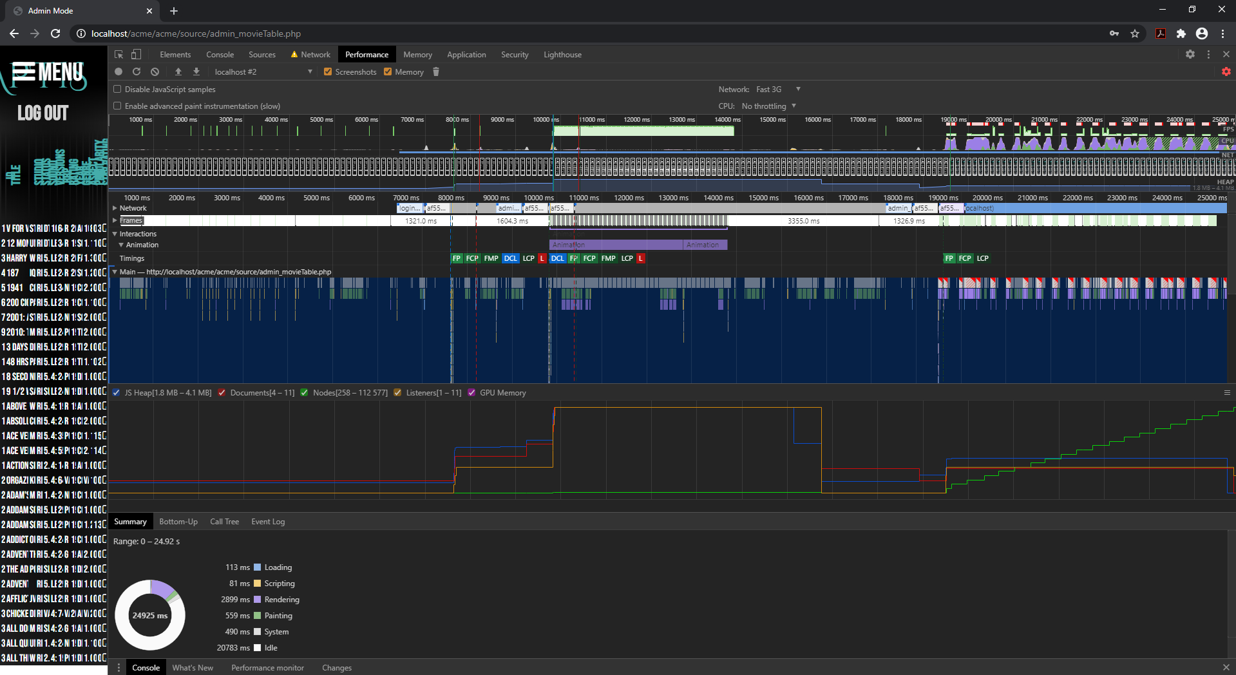

### Network Analytics

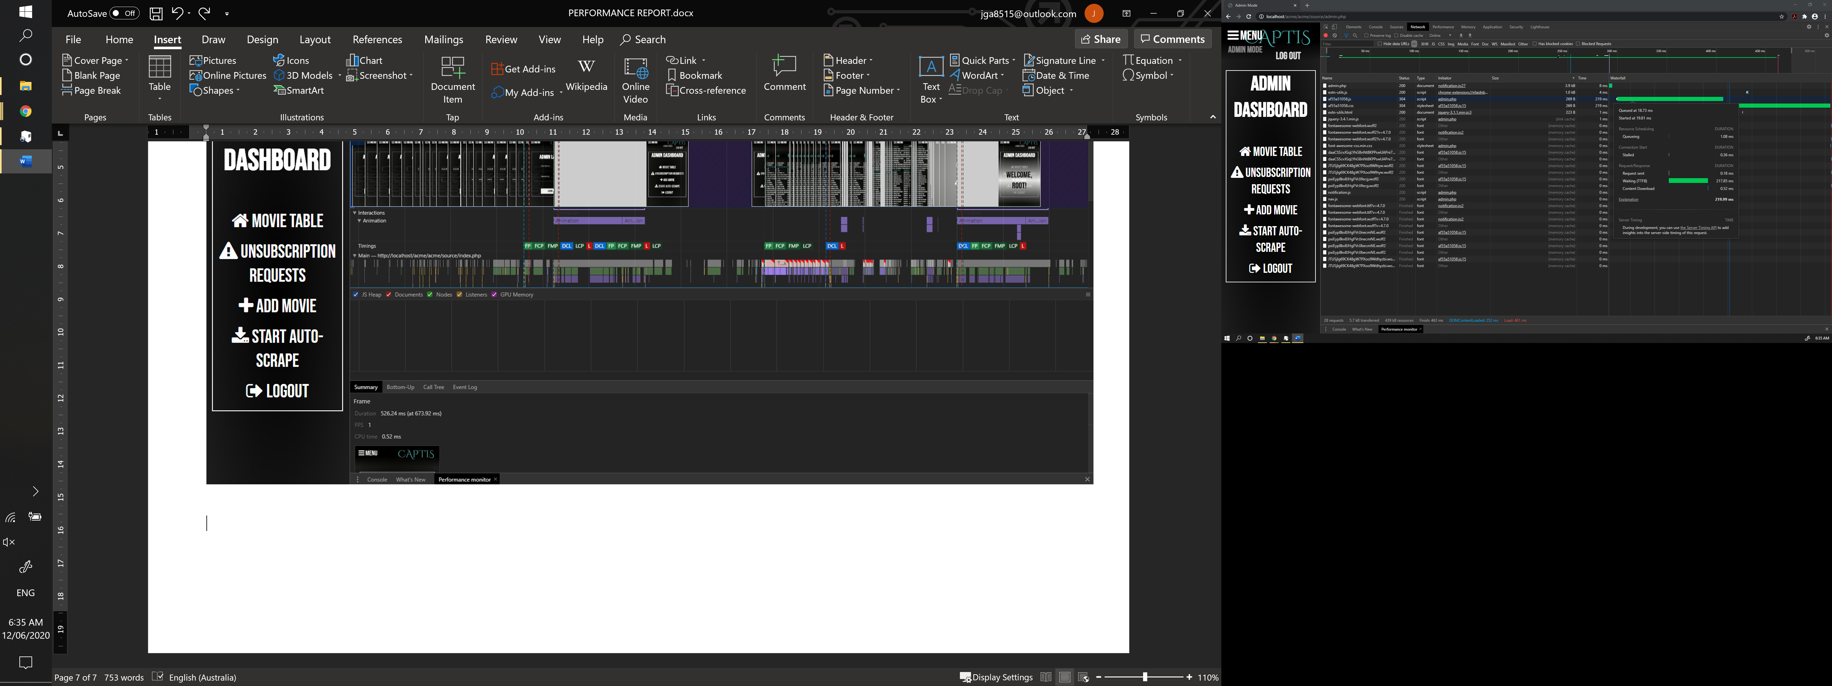

|  |  |
| --- | --- |
|**  |**  |

### Performance Extracts of Index Page

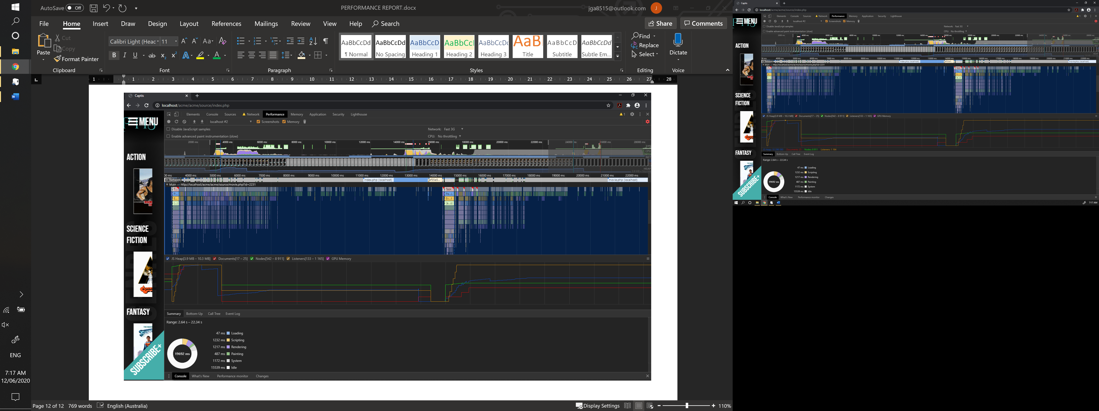

### Network Analytics

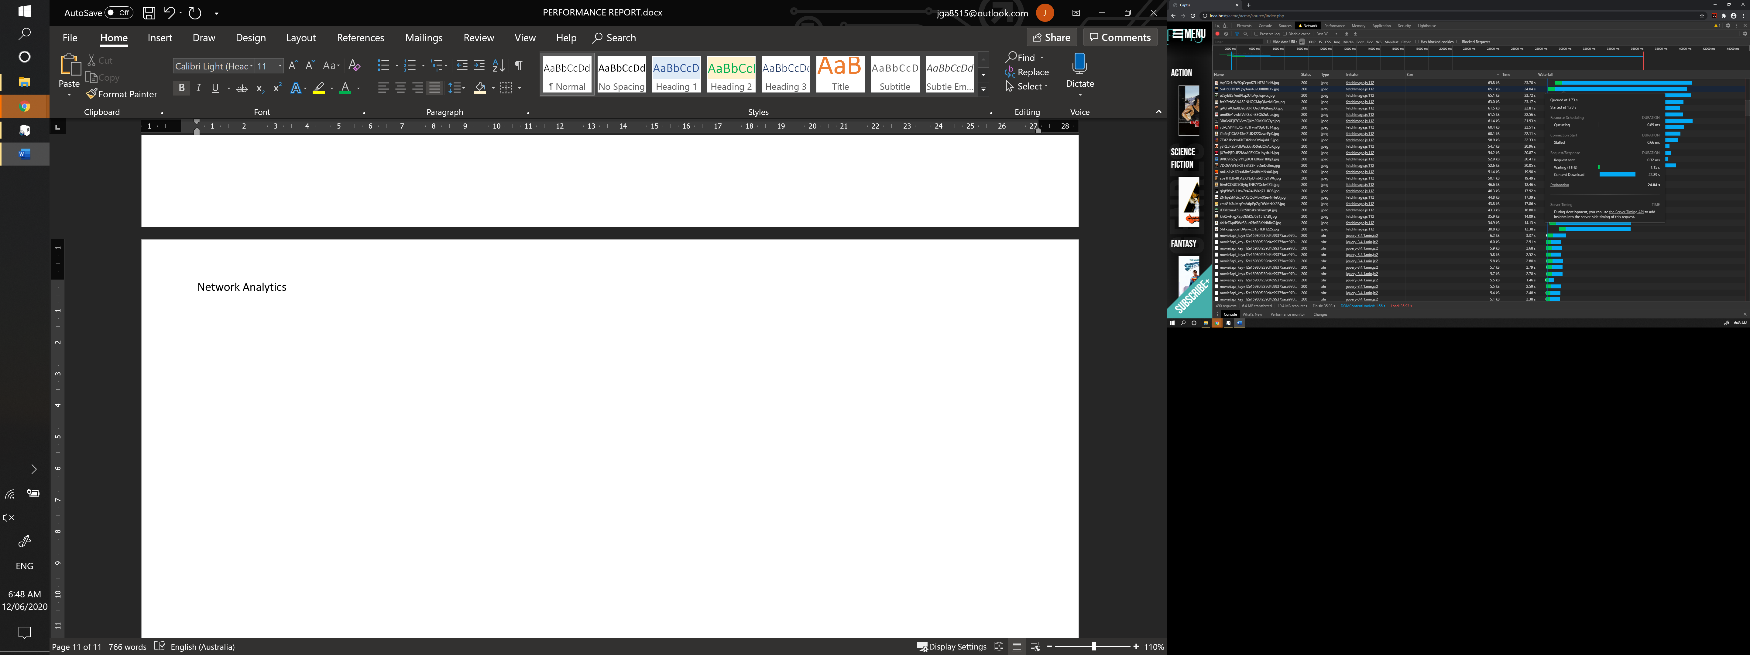

|  |  |
| --- | --- |
|**  |**  |

### Warnings/Error Logging

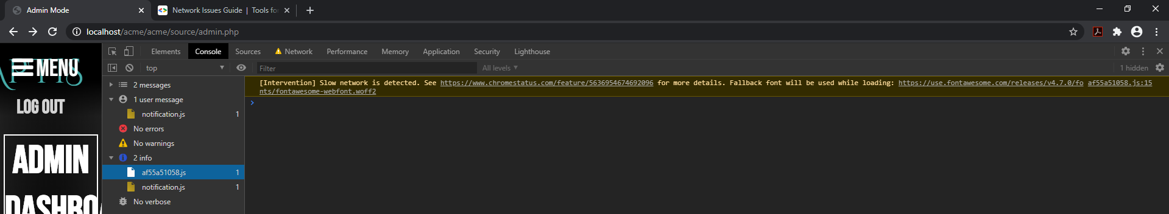

## Software Review – Sprint Two

### Requirements Overview

### Current Requirements (05/06/2020)

|  |  |  |  |
| --- | --- | --- | --- |
|  | Requirement | Completed | Comments/Reference |
| 1 | Index page contains navigation bar. | YES | See ref 1 |
| 2 | Index page includes logo. | YES | See ref 2 |
| 3 | Movies will be categorized by genre, collections or popular. | YES | See ref 3 |
| 4 | Popular movie titles will be numbered by most searched, in the Popular section page. | YES | See ref 4 |
| 5 | Search page will contain search fields for the movie title, genre, rating and year. | YES | See ref 5  Comments: Search form displays low on the screen and not in the middle. |
| 6 | Search page will display search results. | YES | See ref 6 |
| 7 | Search page will allow user to select on result movie titles which will direct them to that selected movie’s information page. | YES | See ref 7 |
| 8 | Search form must allow user to search by any combination of search inputs, whether it is all search field inputs or part’s of.  For example;  Title, genre, rating and year  Title, genre and year  Genre and year  Genre | YES | See ref 8 |
| 9 | If there is no movies within the search input details, a no results page must be shown to the user | YES | See ref 9 |
| 10 | Movie information page will include the movie poster, trailer, rating and details. | YES | See ref 10 |
| 11 | Website must be able to adapt to multiple device screen sizes. | YES |  |

Image Reference 1

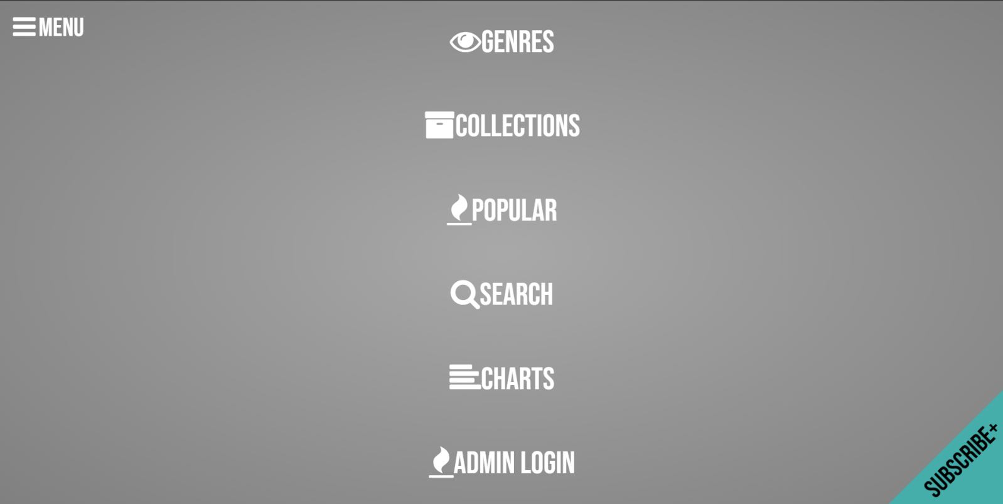

Image Reference 2

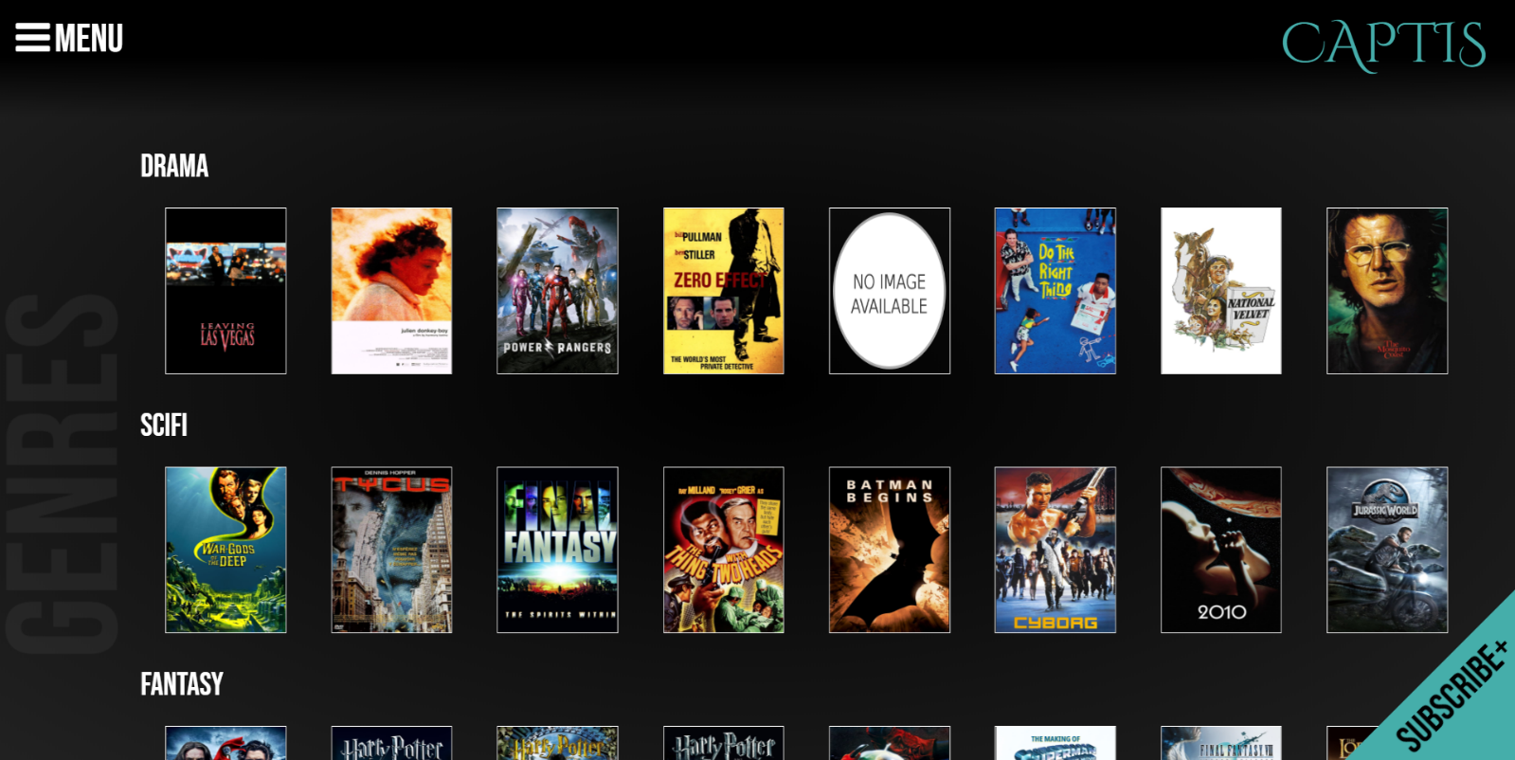

Image Reference 3

Genres

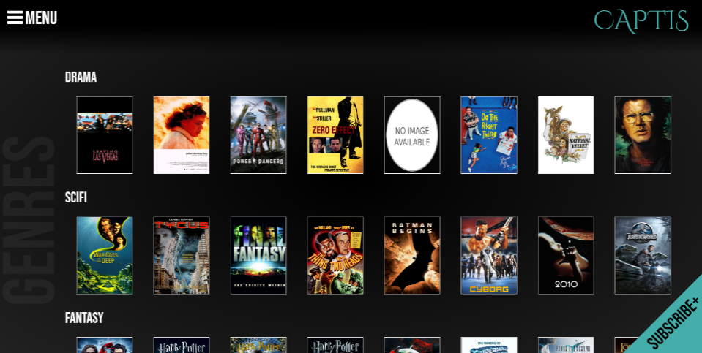

Collection

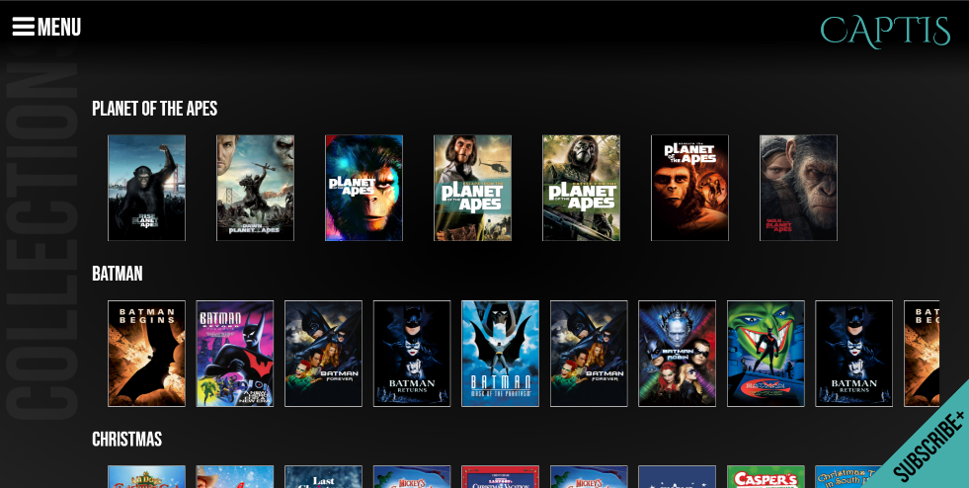

Popular

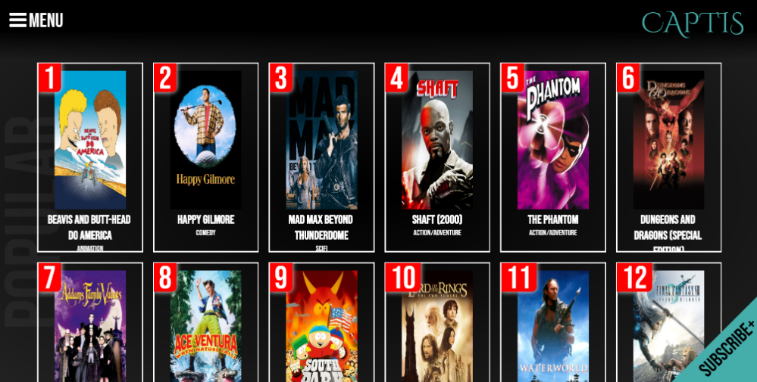

Image Reference 4

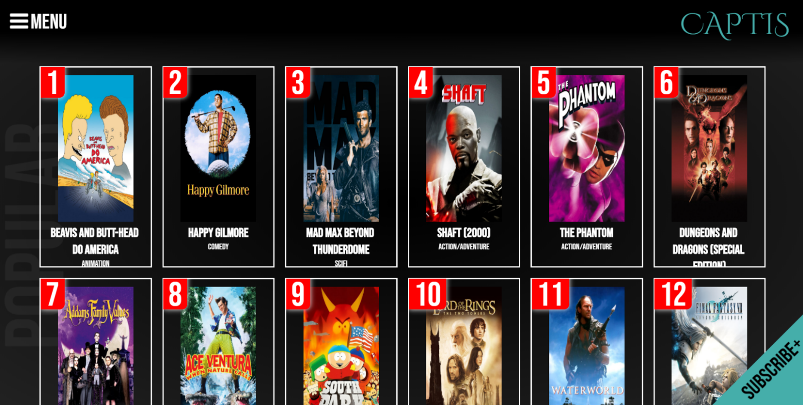

Image Reference 5

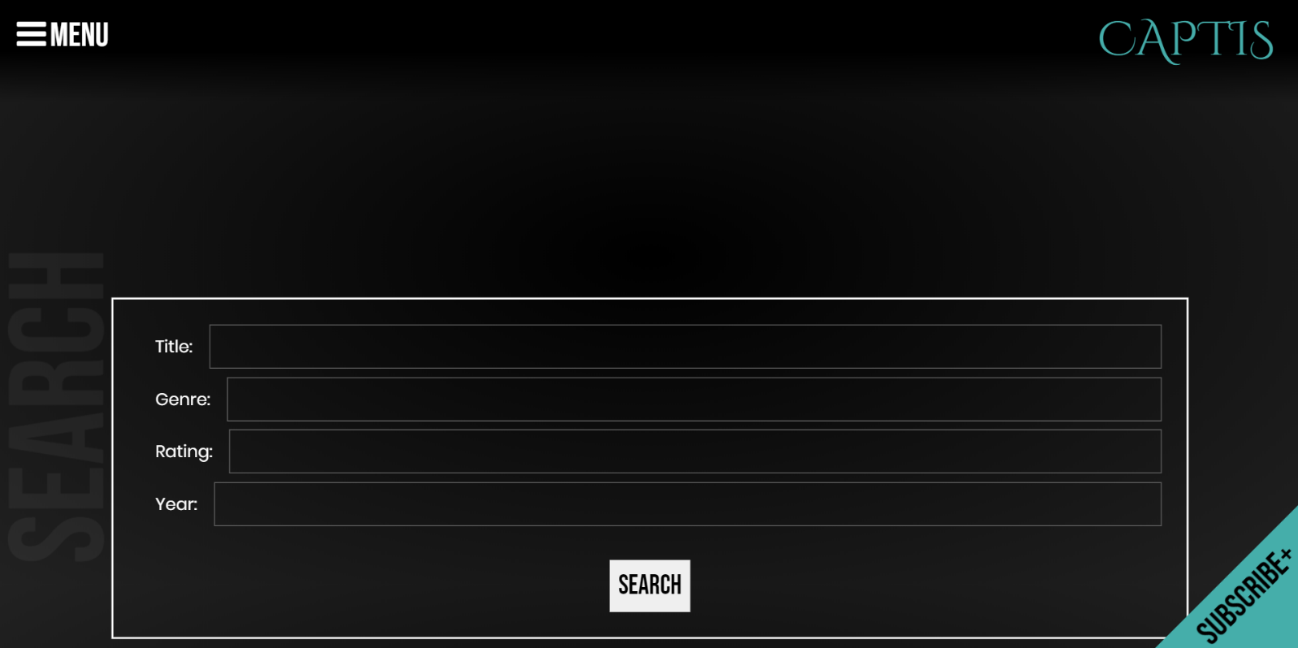

Image Reference 6

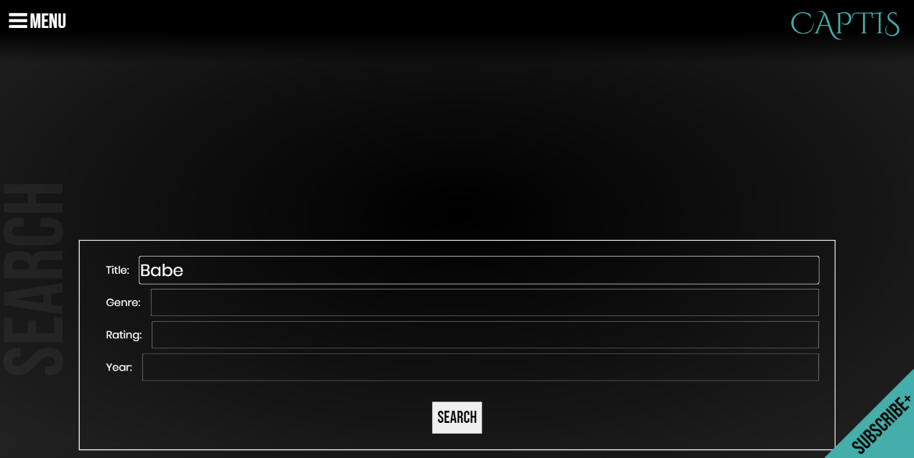

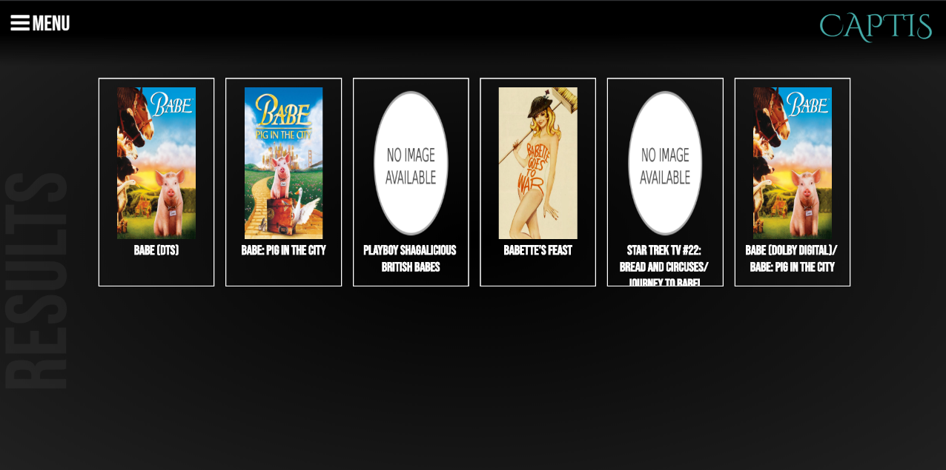

Image Reference 7



Image Reference 8

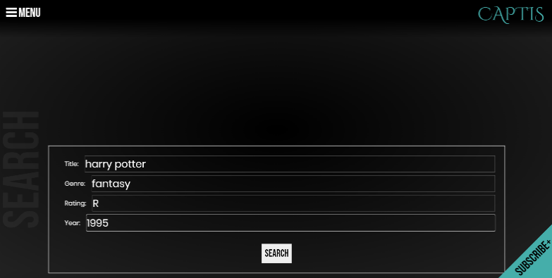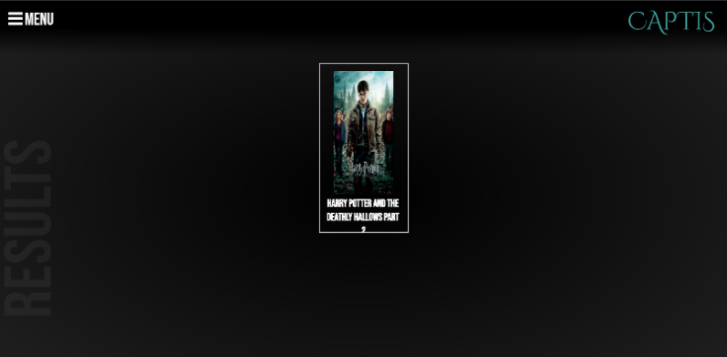

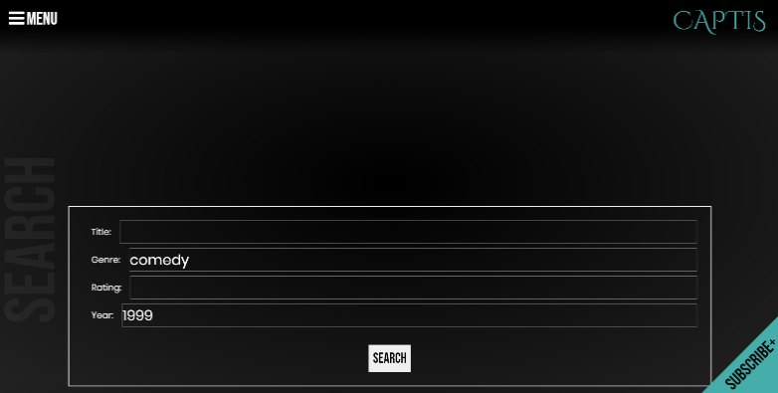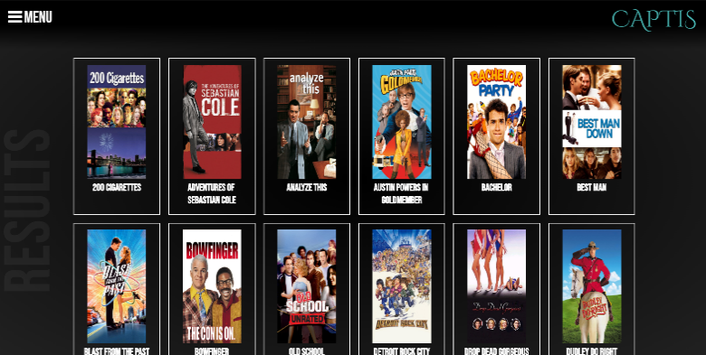

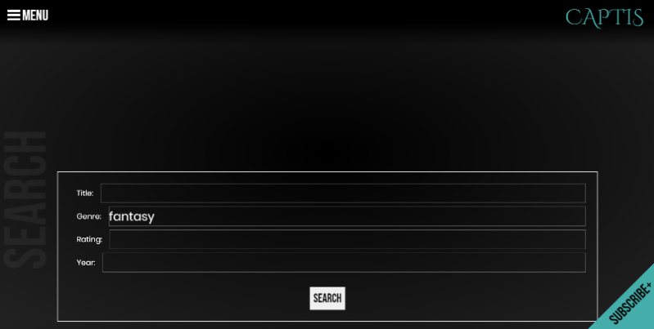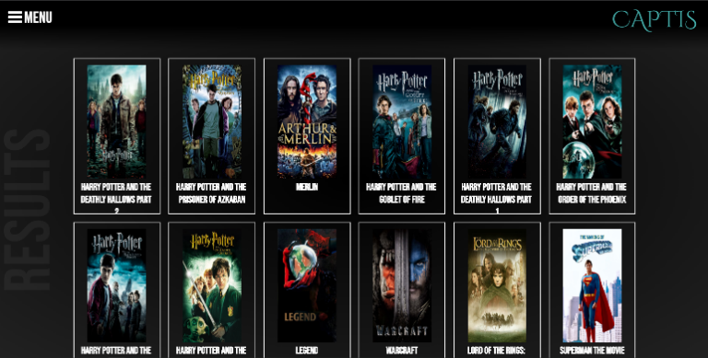

Image Reference 9

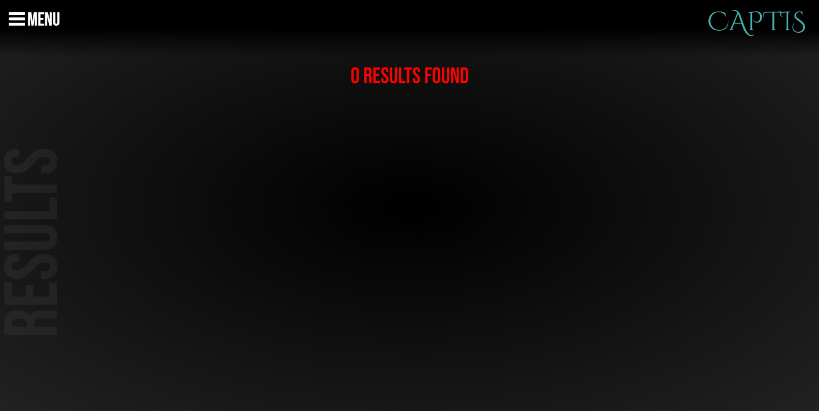

Image Reference 10

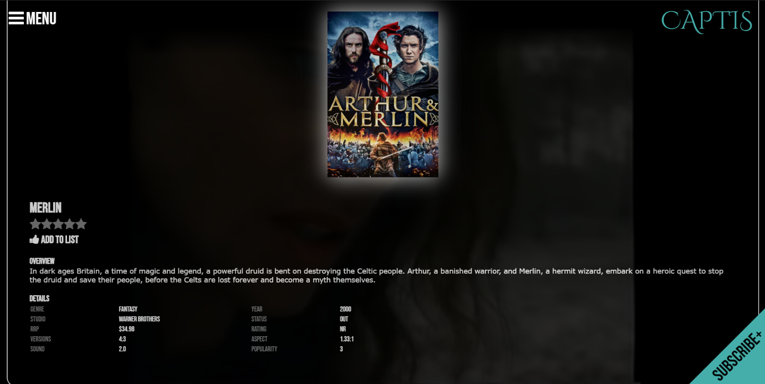

Image Reference 11

PC Screen

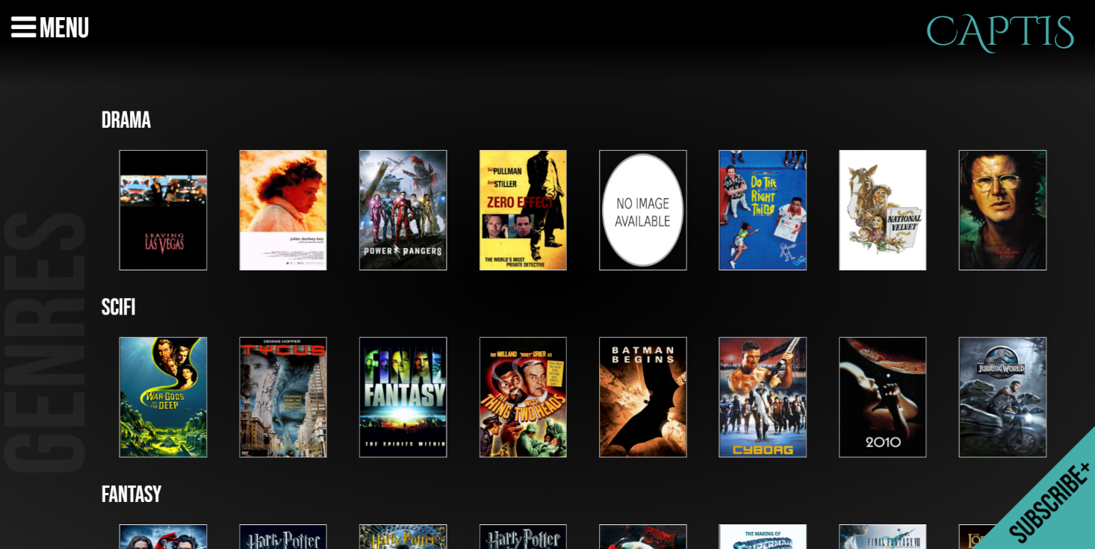

Iphone Ipad

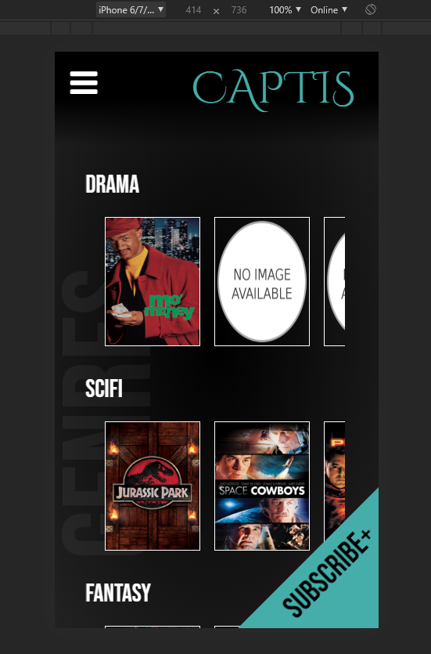 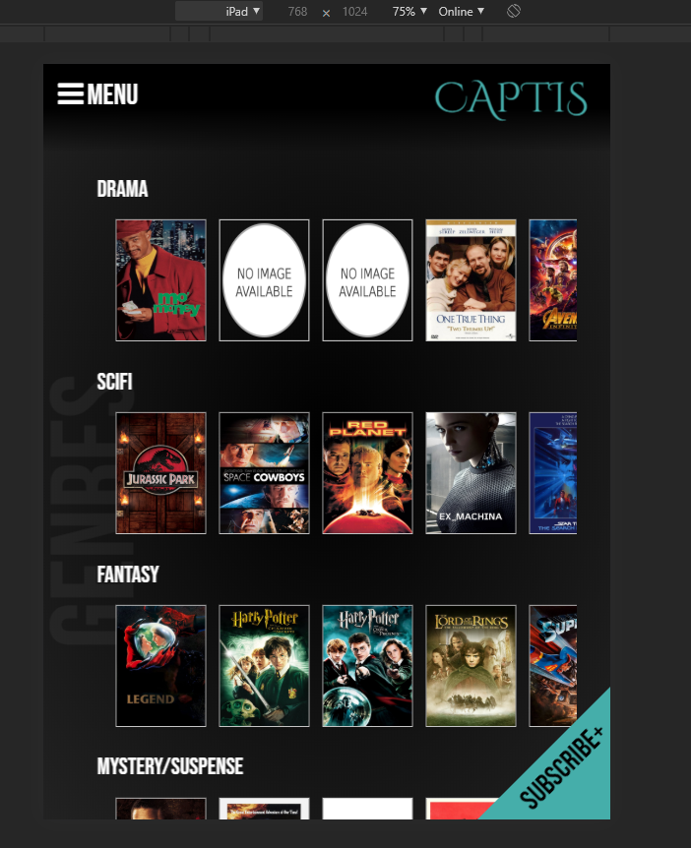

### Test Case

### Test on current user input forms and web multi platform display (05/06/2020)

|  |  |  |  |
| --- | --- | --- | --- |
|  | Test Case | Pass/Fail | Comments |
| 1 | Search form searches movies with all inputs filled | Pass |  |
| 2 | Search form searches movies with either fields filled | Pass |  |
| 3 | Search form displays “no results” to user if there is no movies that match search criteria | Pass |  |
| 4 | Web application displays correctly on PC screen | Pass |  |
| 5 | Web application displays correctly on android devices | Issues to be fixed | All pages display correctly on device, only issue is on the charts page, the genre titles are squished to the left.  See Image Ref 1 |
| 6 | Web application displays correctly on Iphone devices | Issues to be fixed | All pages display correctly on device, only issue is on the charts page, the genre titles are squished to the left.  See Image Ref 2 |
| 7 | Web application displays correctly on tablets/Ipads | Pass |  |

Image Reference 1 Image Reference 2

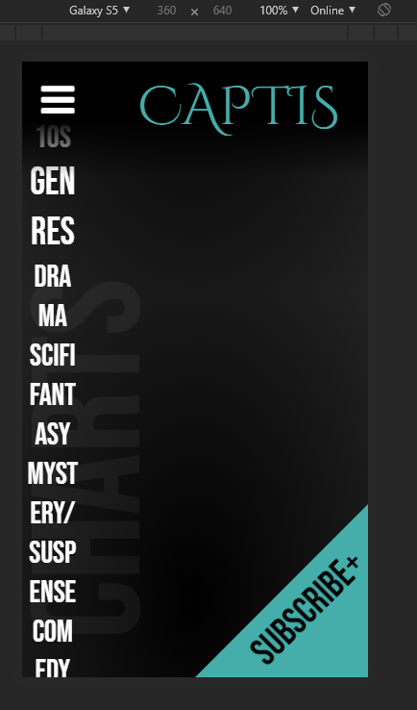 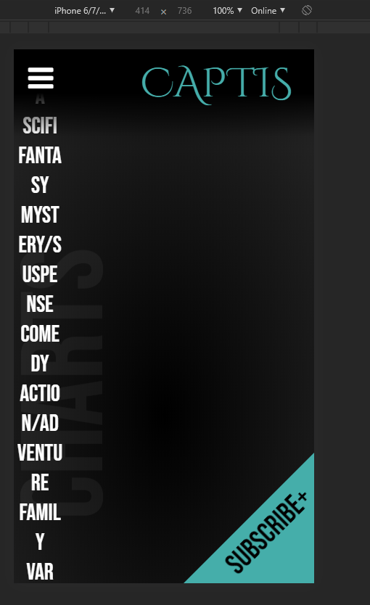

### Updated Client Requirements

Client meeting overview (05-06-2020)

### Updated Client Requirements

* A monthly newsletter and burst newsletter subscription
* Admin page that allows admin to view all users subscribed and allows to remove when users opt to unsubscribe.
* From the given two new client requirements for the movie database project, the following requirements will be added.
* Users will be directed to a subscribe page when they click on the subscribe tab
* Users will be asked for their full name, email and the option to select monthly, burst or both when they submit their subscription details.
* Database must be able to accept all email varieties, e.g Hotmail, gmail, outlook, etc.
* Users are able to unsubscribe to the newsletter, which just requires their email address.
* When a user submits to unsubscribe, an email will be sent out to the admin email that informs that this user wants to unsubscribe.
* On the movie database webpage, there will be a admin page that only allows the admin to see the current subscriptions and allows to delete members when admin receives the unsubscribe email.

# User interface Design mock up

## User Subscribe Page

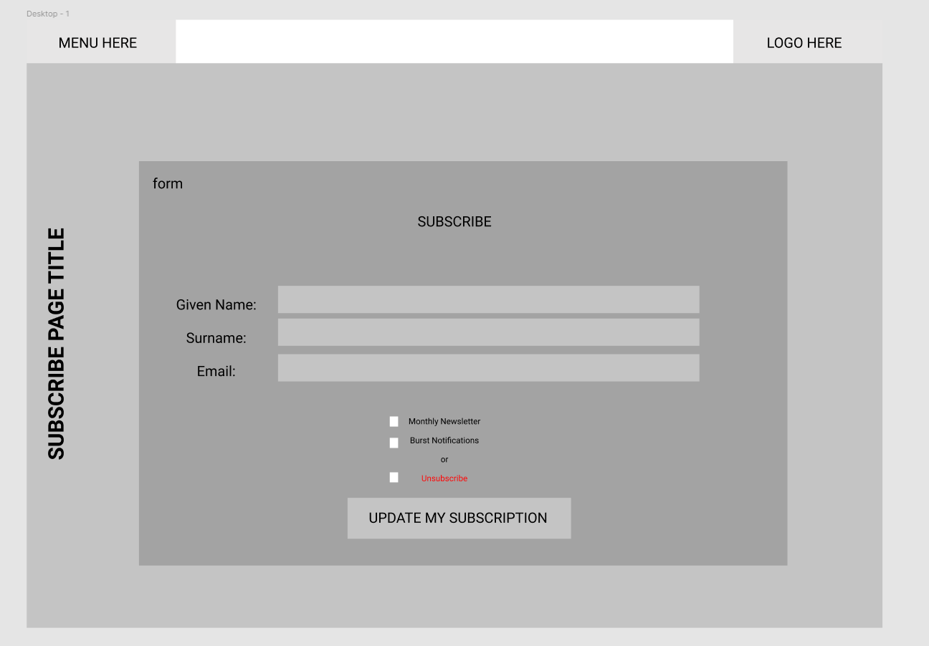

## Admin Login Page

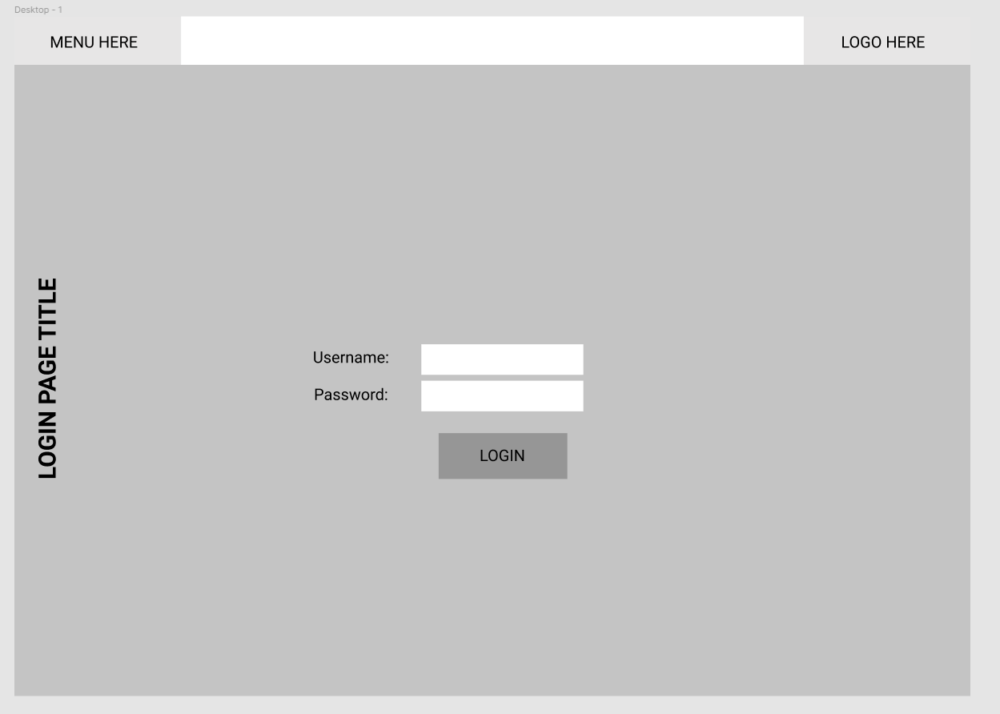

## Admin Page – Main Dashboard

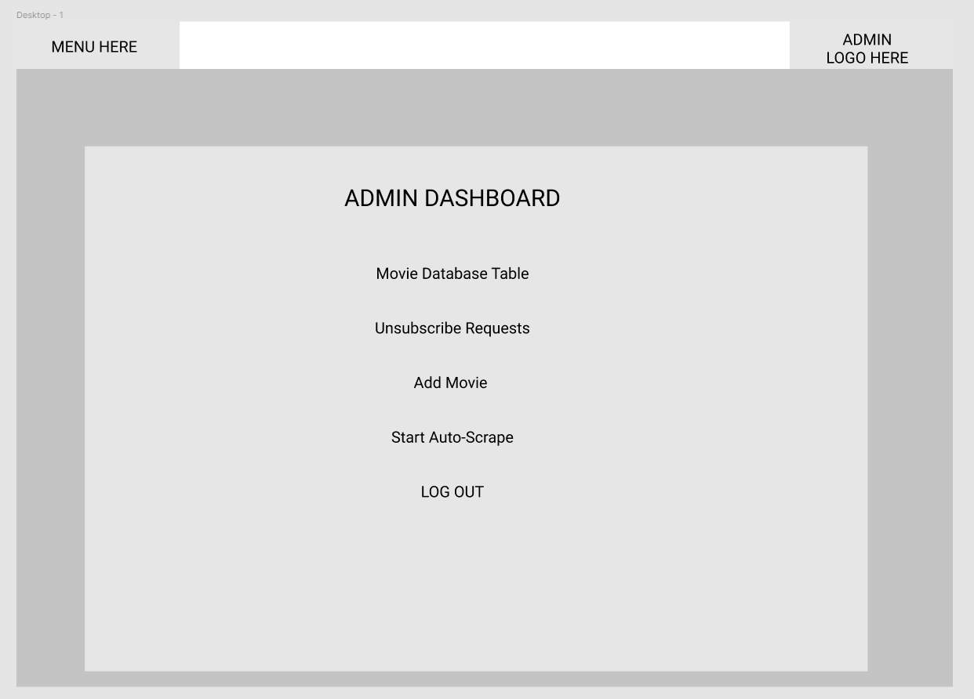

## Movie Database Table

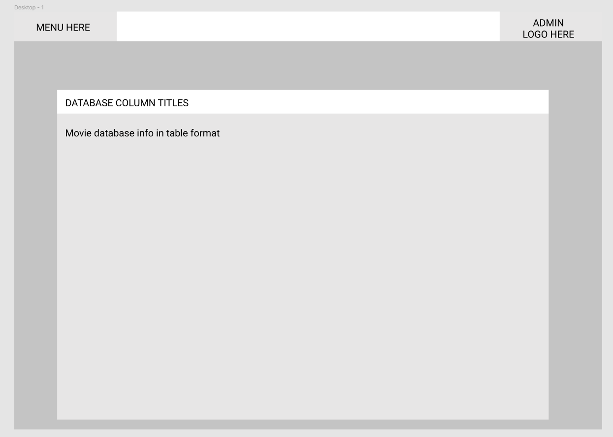

## Subscriber List & Remove from Subscription page

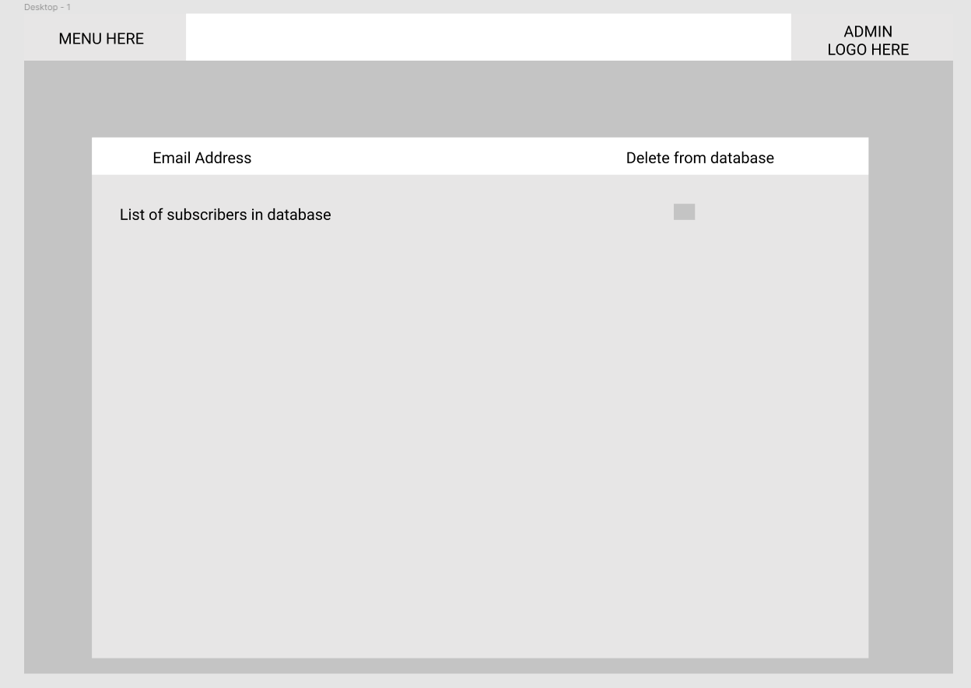

## Add Movie to Database Page

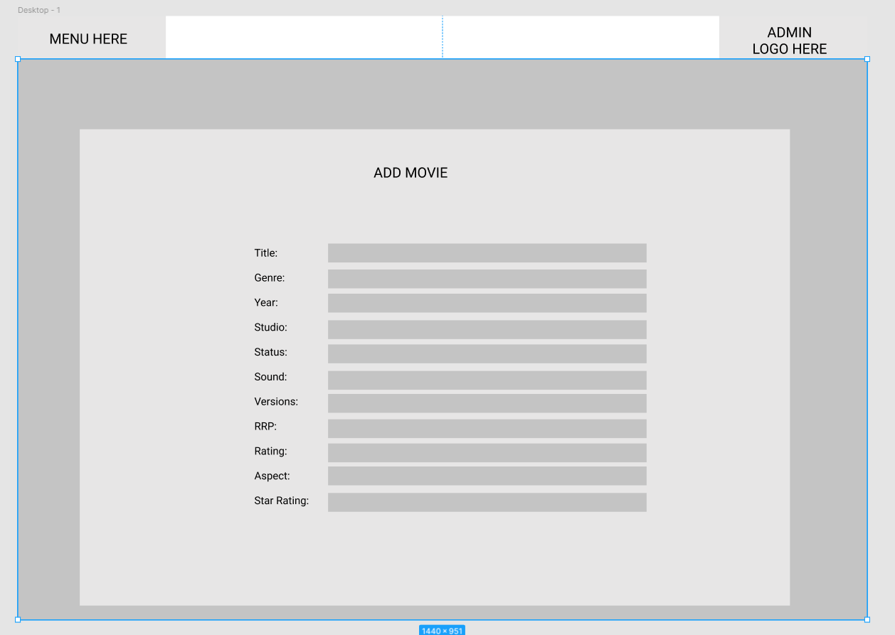

### Business Requirements

### Updated as of 06/06/2020

The below table defines the business requirements for the current sprint.

|  |  |
| --- | --- |
| Code | Requirement Description |
| BR1 | The website must contain a member’s signup page which adds members to the database. |
| BR2 | Selection of monthly notifications. |
| BR3 | Selection of burst notifications. |
| BR4 | Have a remove subscription option. |
| BR5 | This function should email the administrator requesting the removal of the user’s database entry. |
| BR6 | Member’s full name and email address should be validated before entry. |

### Requirements Traceability Matrix

### Updated as of 06/06/2020

Below is the requirements traceability matrix outlining the cases responsible for the testing of the individual business requirements.

|  |  |  |  |
| --- | --- | --- | --- |
| Business Requirement | Test Case # | Defects | Status |
| BR1 | 1 | - | Satisfied |
| BR2 | 3, 4, 5, 8 | - | Satisfied |
| BR3 | 3, 4, 6, 8 | - | Satisfied |
| BR4 | 9, 10 | - | Satisfied |
| BR5 | 9, 10 | - | Satisfied |
| BR6 | 2, 3, 4, 5, 6, 7, 8 | - | Satisfied |

### Test Cases

Updated as of 06/06/2020

|  |  |  |  |  |
| --- | --- | --- | --- | --- |
| # | Functionality | Data used / Input | Expected Result | Pass / Fail |
| 1 | Subscribe | Clicked ‘Subscribe+’ button | Navigates to subscription form. | PASS |
| 2 | Subscribe | Subscribe with:   * Invalid first name * Valid last name * Valid email address * Monthly box ticked * Burst box ticked | Error showing invalid name. Subscription does not continue. | PASS |
| 3 | Subscribe | Subscribe with:   * Valid first name * Invalid last name * Valid email address * Monthly box ticked * Burst box ticked | Error showing invalid name. Subscription does not continue. | PASS |
| 4 | Subscribe | Subscribe with:   * Valid first name * Valid last name * Invalid email address * Monthly box ticked * Burst box ticked | Error showing invalid email address. Subscription does not continue. | PASS |
| 5 | Subscribe | Subscribe with:   * Valid first name * Valid last name * Valid email address * Monthly box ticked * Burst box un-ticked | Notification stating subscription has been successful. User is added to the database table ‘subscriptions’, showing 1 for monthly, 0 for burst. | PASS |
| 6 | Subscribe | Subscribe with:   * Valid first name * Valid last name * Valid email address * Monthly box un-ticked * Burst box ticked | Notification stating subscription has been successful. User is added to the database table ‘subscriptions’, showing 0 for monthly, 1 for burst. | PASS |
| 7 | Subscribe | Subscribe with:   * Valid first name * Valid last name * Valid email address * Monthly box un-ticked * Burst box un-ticked | Notification stating subscription has been successful. User is added to the database table ‘subscriptions’, showing 0 for monthly, 0 for burst. | PASS |
| 8 | Subscribe | Subscribe with:   * Valid first name * Valid last name * Valid email address * Monthly box ticked * Burst box ticked | Notification stating subscription has been successful. User is added to the database table ‘subscriptions’, showing 1 for monthly, 1 for burst. | PASS |
| 9 | Unsubscribe | Unsubscribe with:   * Email address not on subscription list | Notification saying request has been sent to administration. | PASS |
| 10 | Unsubscribe | Unsubscribe with:   * Email address on subscription list | Notification saying request has been sent to administration. | PASS |

# 1.2 Sprint Three

### Project Management Plan

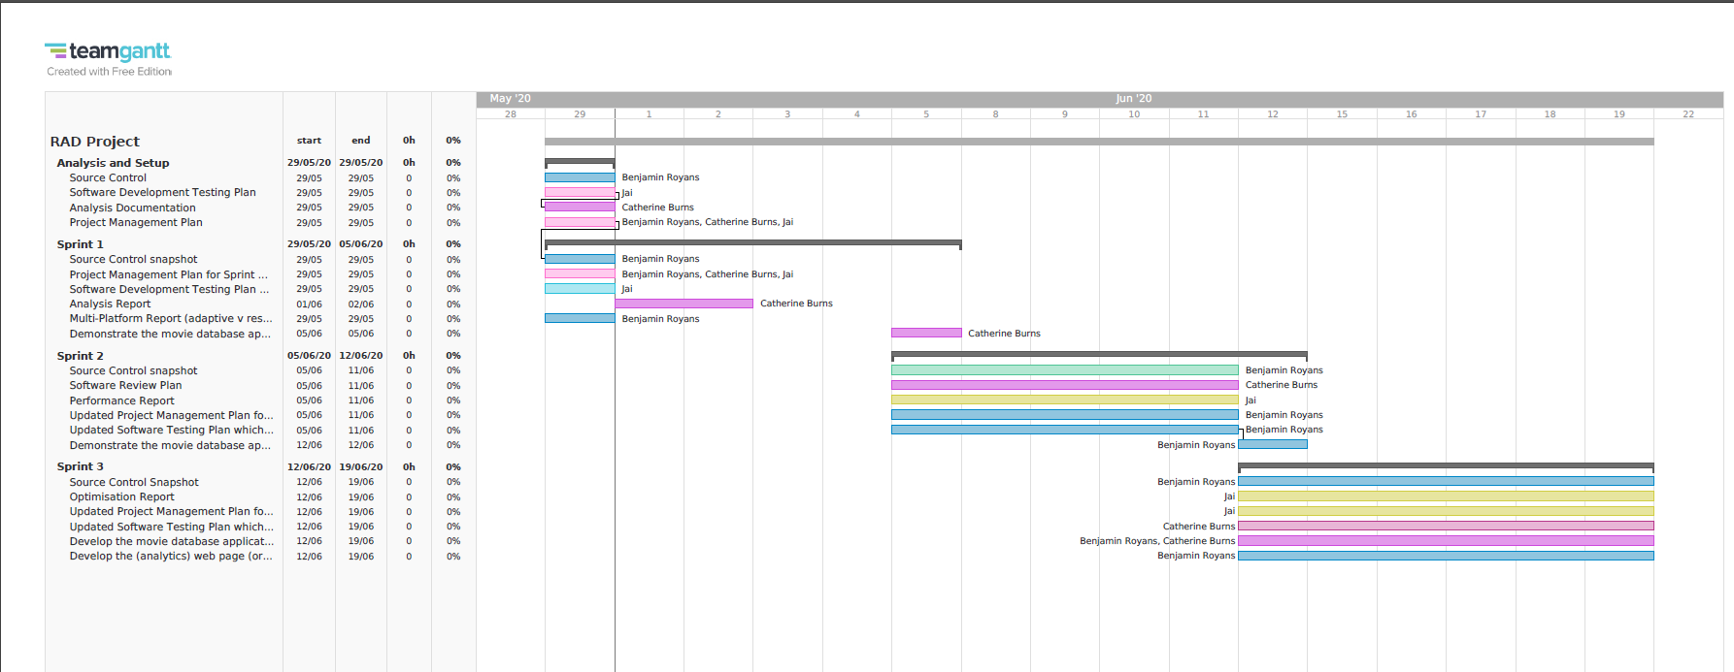

### Source Control Screenshot

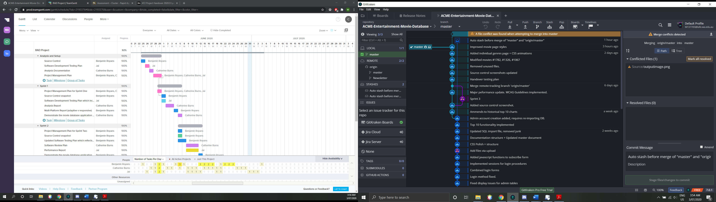

## Test Plan

### In Scope

The following items will be included during the testing phase:

* Admin login functionality
  + Admin login with credentials
  + Admin gain access to privileged administrative pages
  + New admin can be created
  + Users will have access to the user web pages
* A web page that displays the top 10 popular movies
* Users are able to rate movies
* Popular movies are rated from the user ratings.
* Popular movies table will updated according to new ratings being entered.

### Out of Scope

Anything NOT outlined in the above scope section will NOT be tested.

### Quality Objective

The objective of testing this application is to ensure it satisfies all requirements (both functional and non-functional) and also meets the quality standards as defined by the client. Through rigorous testing patterns any bugs, issues and un-expected behaviour will be identified and corrected. This approach will help us to deliver a quality application as the final product that exceeds customer expectations.

### Roles and Responsibilities

**Scrum Master**

The current scrum master is Jai Ananda.

#### **Responsibilities**

* Optimisation Report
* Update project management plan
* Client demonstration

**Developers**

The current developers are Catherine Burns and Ben Royans.

#### **Responsibilities**

* Programming
* Software testing plan
* Develop the (analytics) web page

# Business Requirements

## Business Requirement Identifcation

The below table defines the business requirements for the current sprint.

|  |  |
| --- | --- |
| **Code** | **Requirement Description** |
| BR1 | The website must contain a login for admin. |
| BR2 | New admin can be created. |
| BR3 | Username and password should be validated before entry. |
| BR4 | Admin has access to admin pages. |
| BR5 | Users can rate movies. |
| BR6 | Top 10 popular movies page loads the top 10 user rated movies. |
| BR7 | This Top 10 chart must update according to when users rate movies. |

## Requirements Traceability Matrix

Below is the requirements traceability matrix outlining the cases responsible for the testing of the individual business requirements.

|  |  |  |  |
| --- | --- | --- | --- |
| **Business Requirement** | **Test Case #** | **Defects** | **Status** |
| BR1 | 1 | - | Satisfied |
| BR2 | 2, 3 |  |  |
| BR3 | 4, 5, 6 | - | Satisfied |
| BR4 | 7 | - | Satisfied |
| BR5 | 8 | - | Satisfied |
| BR6 | 9 | - | Satisfied |
| BR7 | 10 | - | Satisfied |

# Test Cases

## Test Case Results Table

|  |  |  |  |  |
| --- | --- | --- | --- | --- |
| **#** | **Functionality** | **Data used / Input** | **Expected Result** | **Pass / Fail** |
| 1 | Admin Login | Webpage contains login page | Page loads with login form | PASS |
| 2 | Create Admin | Create admin with:   * Valid username and password | New admin is created. | PASS |
| 3 | Create Admin | Create admin with:   * Valid username * Invalid password | Error showing invalid password type. New admin is not created. | PASS |
| 4 | Admin Login | Login with:   * Correct admin creditals | Login is successful and admin has access to admin pages | PASS |
| 5 | Admin Login | Login with:   * Incorrect username * Correct Password | Error showing invalid username. Login does not continue. | PASS |
| 6 | Admin Login | Login with:   * Correct username * Incorrect Password | Error showing invalid password. Login does not continue. | PASS |
| 7 | Admin Login | Admin has access to:   * Movie Table * Unsubscription Requests * Add Movie * Start Auto-Scrape | Admin has access to all admin pages. | PASS |
| 8 | User | User can rate a movie | When movie is rated, the database updates. | PASS |
| 9 | Top 10 Popular Movies Page | Top 10 movies are displayed according to their user rating | Page loads with top 10 movies. | PASS |
| 10 | Top 10 Popular Movies Page | Top 10 chart changes according to any additional ratings. | Chart updates and changes occur when ratings change. | PASS |

## Test Case Screenshots

|  |  |
| --- | --- |
| **#** | **Screenshot** |
| 1 |  |
| 2 |  |
| 3 |  |
|  |  |
| 4 |  |

|  |  |
| --- | --- |
| 5 |  |

|  |  |
| --- | --- |
| 6 |  |

|  |  |
| --- | --- |
| 7 |  |

|  |  |
| --- | --- |
| 8 |  |
| 9 |  |

|  |  |
| --- | --- |
| 10 |  |

## Performance Report

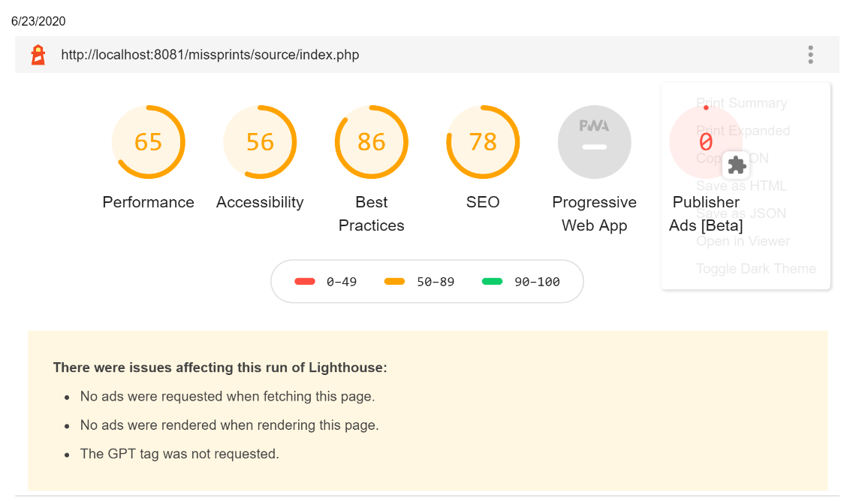

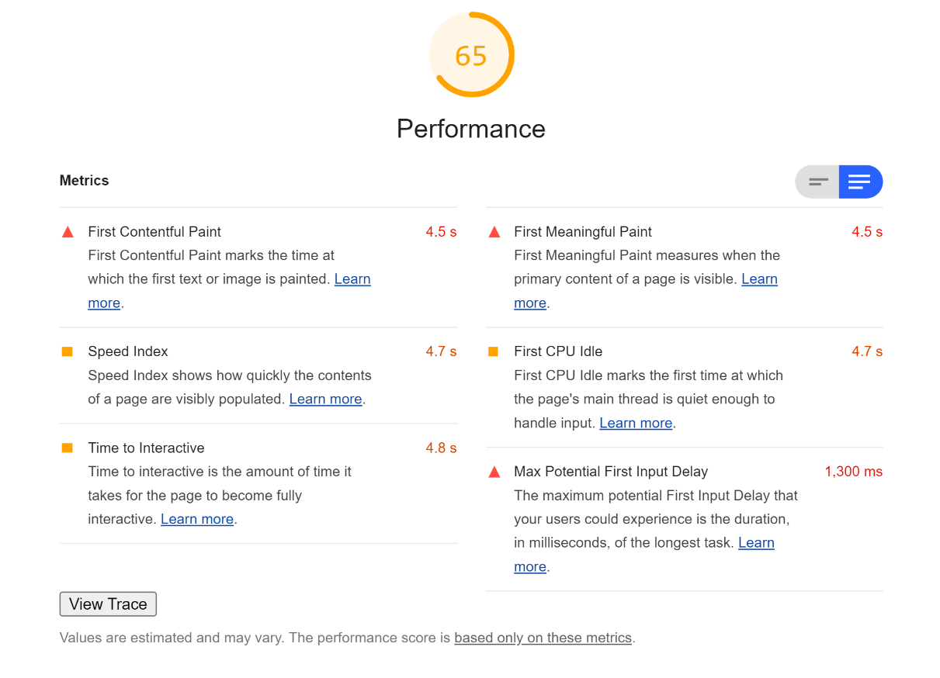

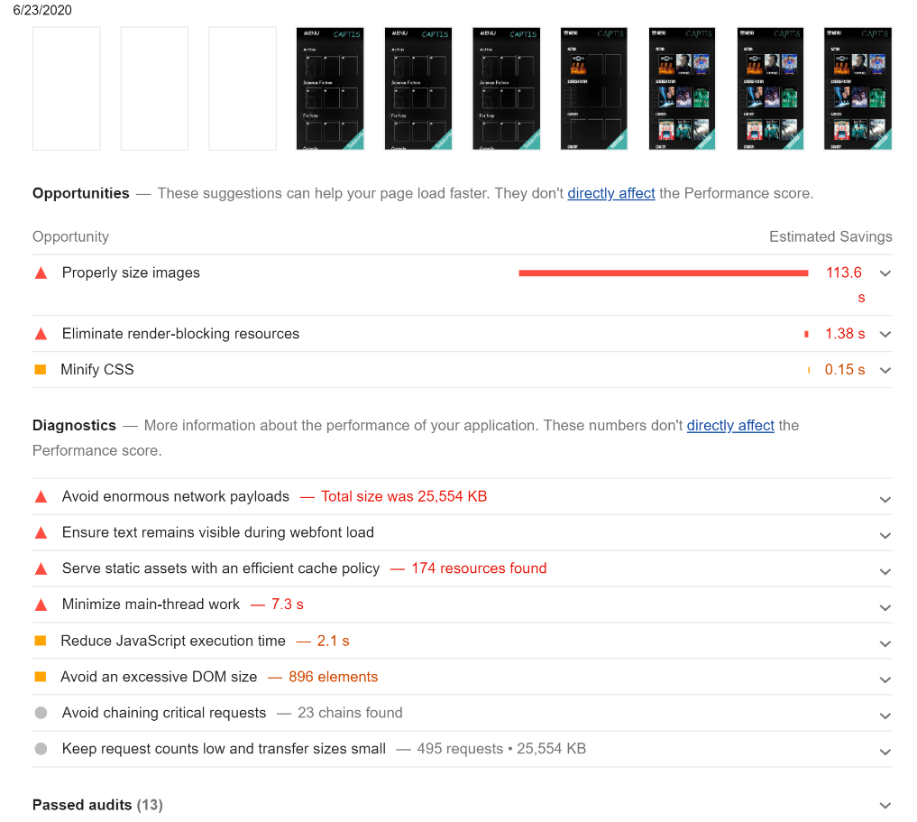

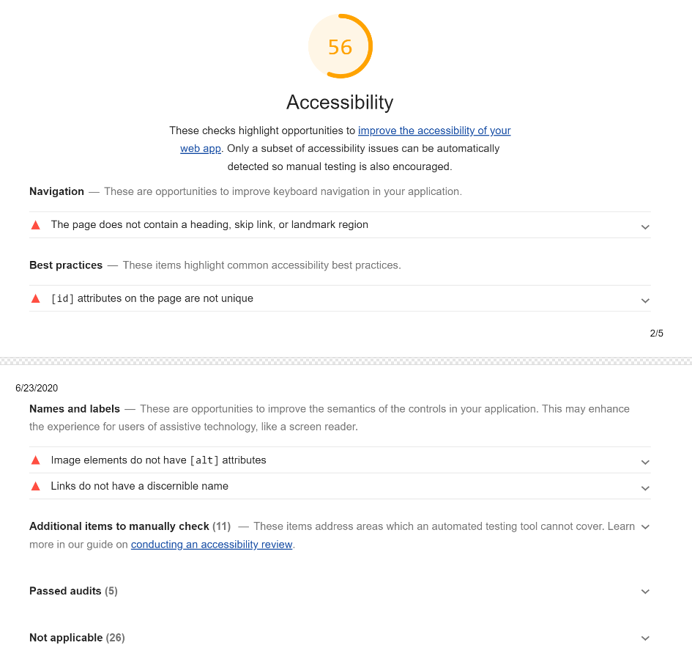

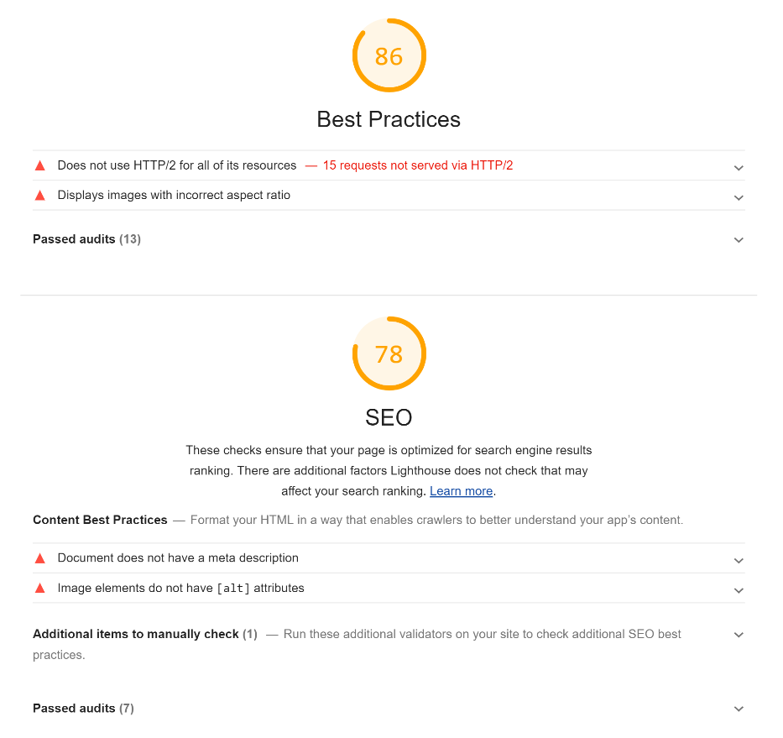

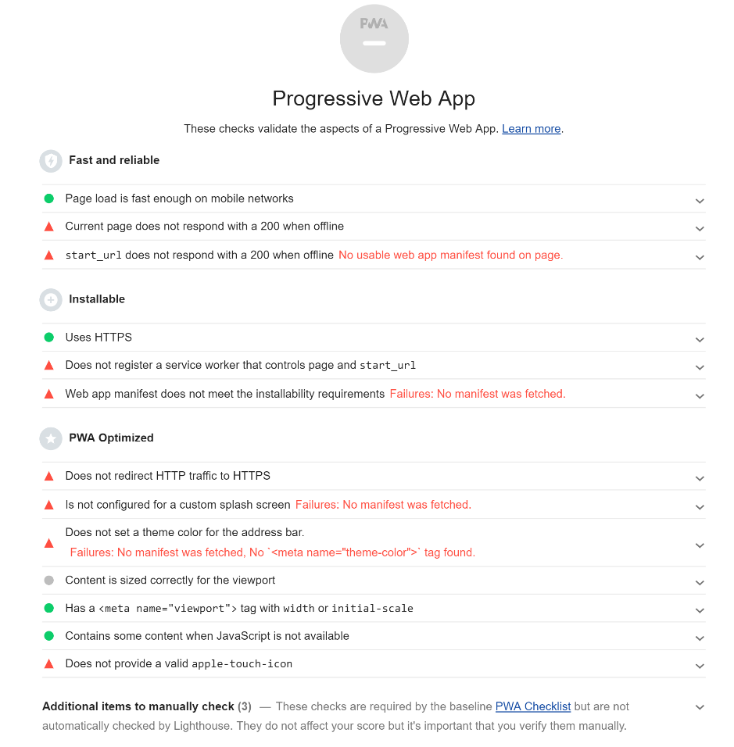

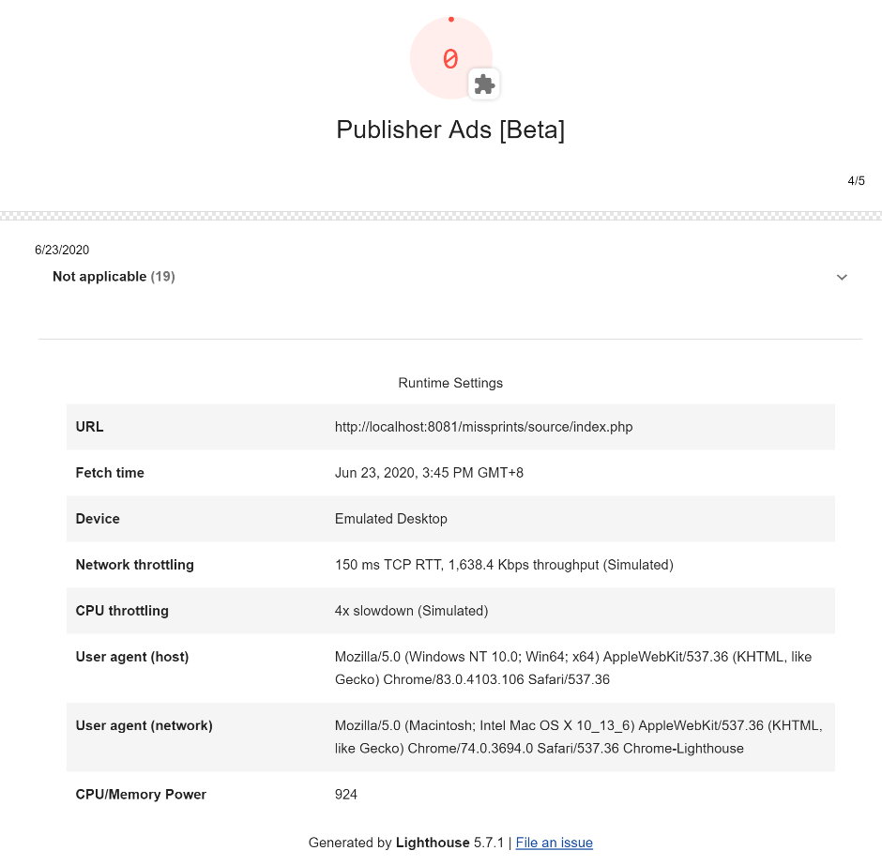

## Optimization Report

### Definition

Performance optimization measures the performance of the server side scripts using various tool in different environments. It is performed by running the codes several times and observing the average execution time to create a benchmark.

### Need for Optimization

1. To make applications fast and efficient
2. It appeals the consumers: speedy campaigns implies higher selling speed

### Case Studies

* Bing found that searches that were 2 seconds slower resulted in a 4.3% drop in revenue per user.
* When Mozilla shaved 2.2 seconds off their landing page, Firefox downloads increased 15.4%.
* Shopzilla saw conversion rates increase 7-12% as a result of their web performance optimization efforts.
* Making Barack Obama’s website 60% faster increased donation conversions 14%. (stevesouders, 2013)

### Best practices

* + Using latest PHP – PHP 7.x versions
  + Using JSON data types instead of XML
  + Using caching systems
  + Closing the DB connection and limit the DB hits

### Performance Tuning steps followed

To keep a check and eliminate slow loading pages, inaccessible pages, unresponsive links and many other factors that would limit the applications downside and work fast and efficient for ACME Entertainment, below tuning tips were considered to monitor our coding performance:

1. Bottlenecks – Identifying impediments and finding the root cause
2. Profiling – What fits ACME Entertainment’s needs. Prefix was looked into as a profiling tool
3. Code Optimization- code was optimized so that it utilizes memory, executes more rapidly, and also performs fewer input and output operations
4. Configure Optimization- optimize the performance of your application, as well as ensure the reliability and cost-effectiveness of your applications system storage
5. Distributed Computing - Increase the potential for parallel execution
6. Catching Strategy - reduce the number of database operations and code compilation
7. Load Balancing - Load balancing is configured in the plugins using various techniques to prioritize by avoiding session objects (stored in local memory)
8. Avoiding Client-side - constantly check and remove or lessen the redirection of your pages
9. Security - responsible for processing users request in a web page or in the browser
10. SQL - dynamic management views (DMVs) which provides provide data about query stats, executing plans, and many more
11. Content Delivery Network - reduce latency, reduce bandwidth consumption, and secure apps while it can also block spammers and other that attack your system
12. Error handling - allows you to develop and improve error reporting that best suit the needs

## Performance Optimization Techniques followed

* Latest versions used
* Used double Quotes (“) and Single quotes (‘)
* Avoided Relative Paths in File Inclusion
* Releasing all Resources
* Avoided Unnecessary Use of Global Variables
* Never used Count or Any Other Methods in The Condition Section of a Loop
* Used ISSET
* Used More Static Methods/Properties
* foreach > for > while implementations

### Previous Observations

### Performance Extracts of Admin Page



### Network Analytics



|  |  |
| --- | --- |
|  |  |

### Performance Extracts of Index Page – Initial Historical Observation



### Network Analytics



|  |  |
| --- | --- |
|  |  |

### Warnings/Error Logging



### Current performance Extracts of Index Page – Under Shared memory

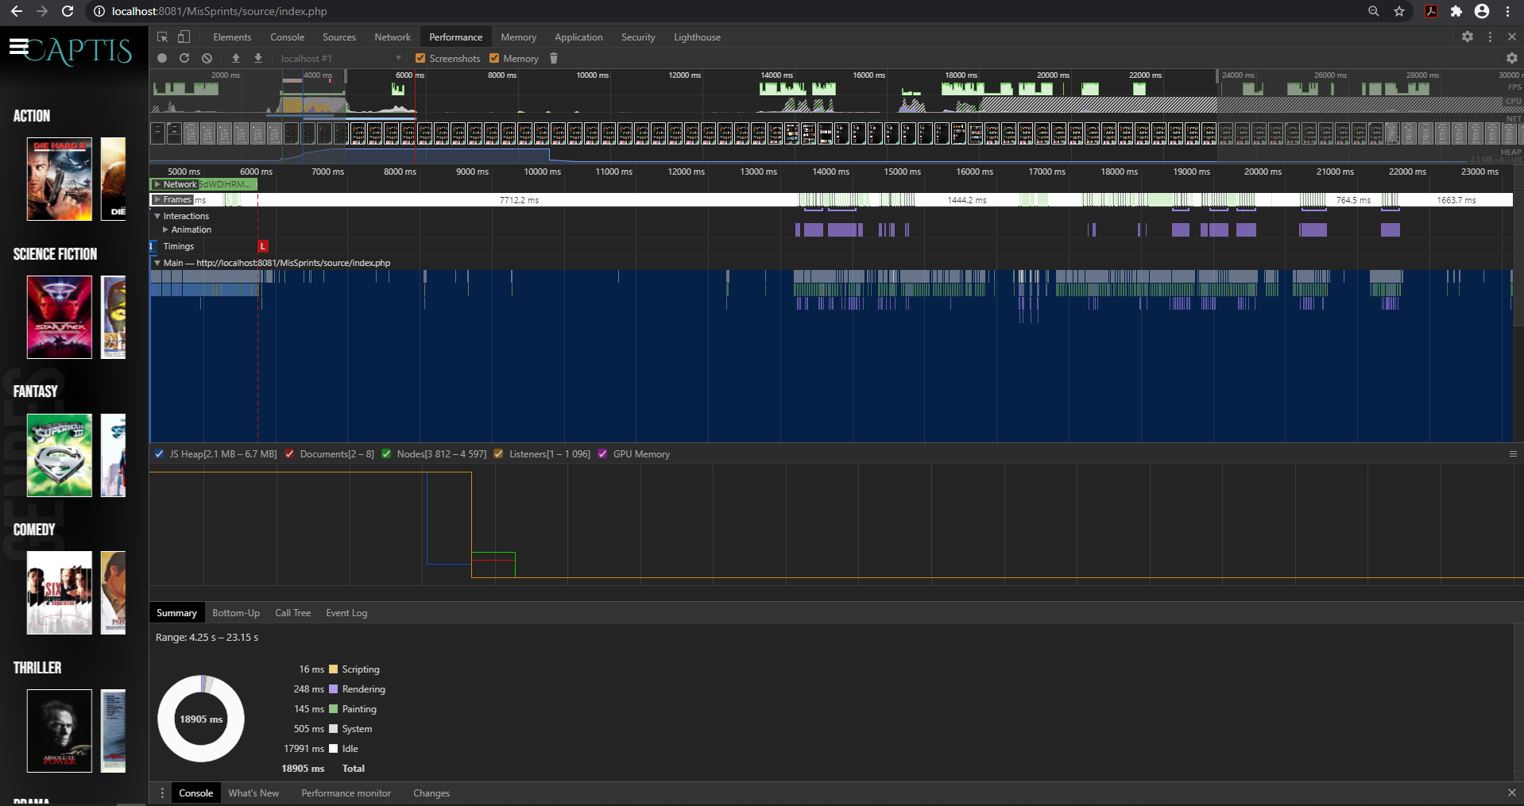

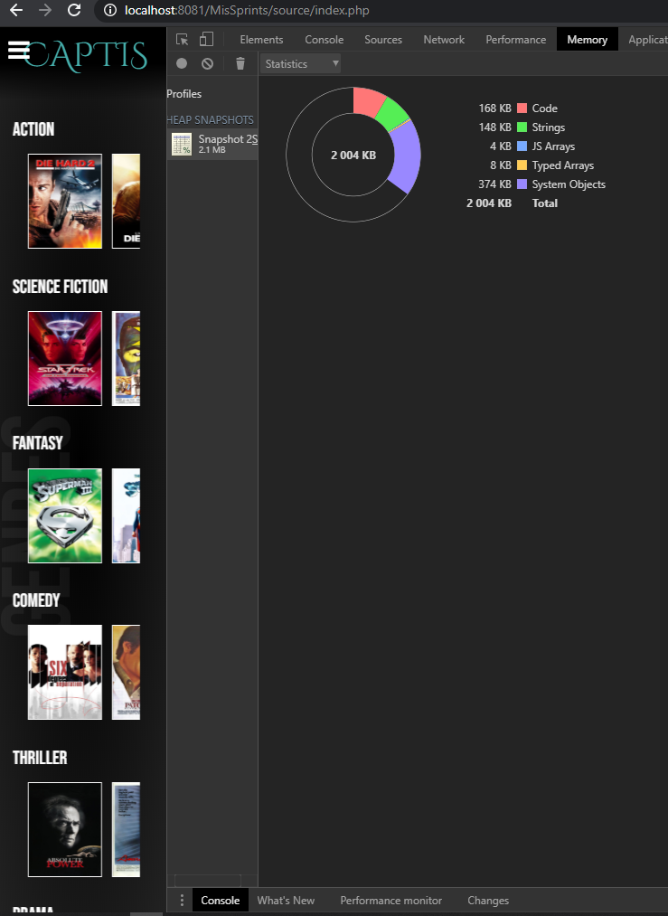

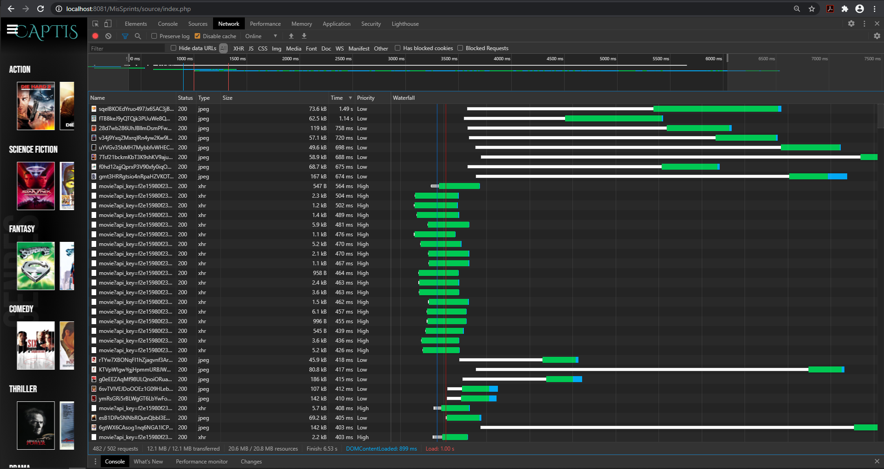

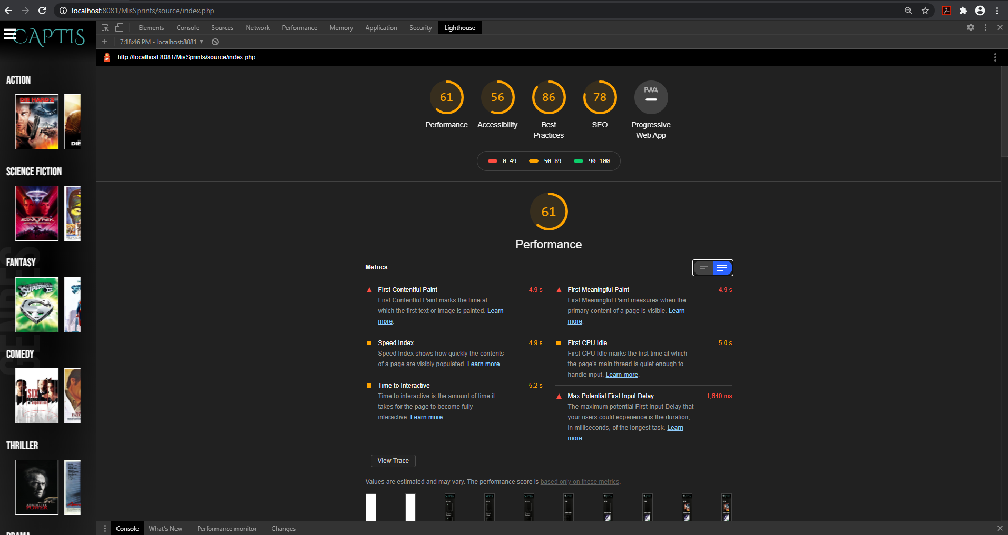

### Current performance Extracts of Index Page – Under Unshared memory

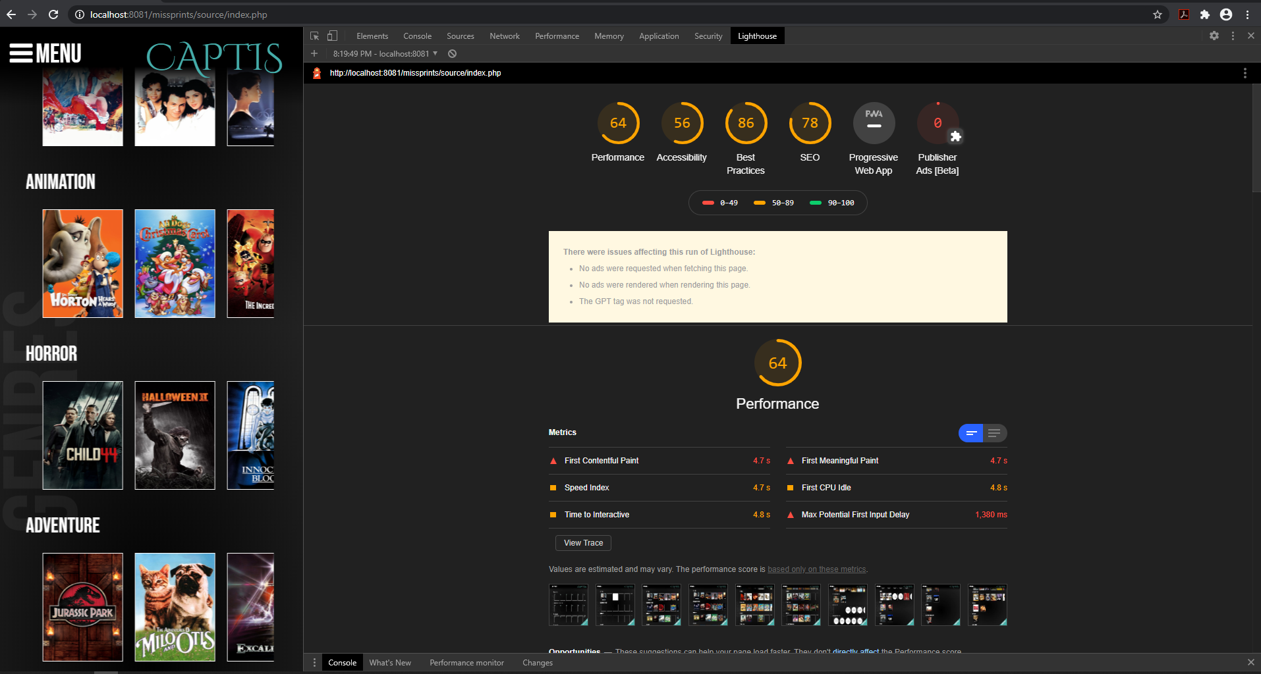

# 1.3 Handover

### Project Management Plan

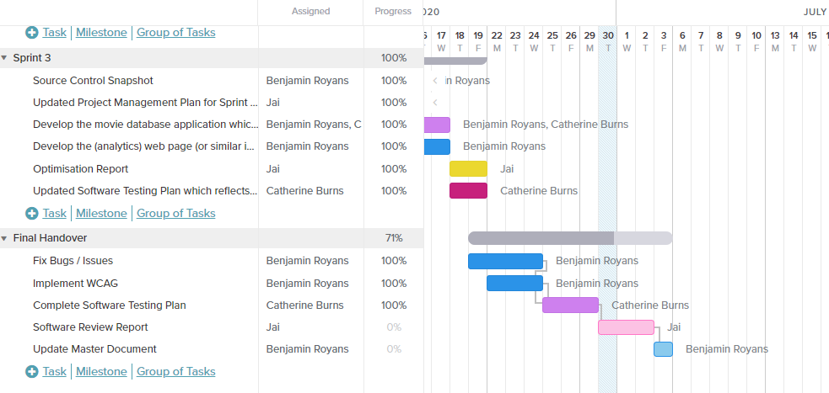

### Source Control Snapshot

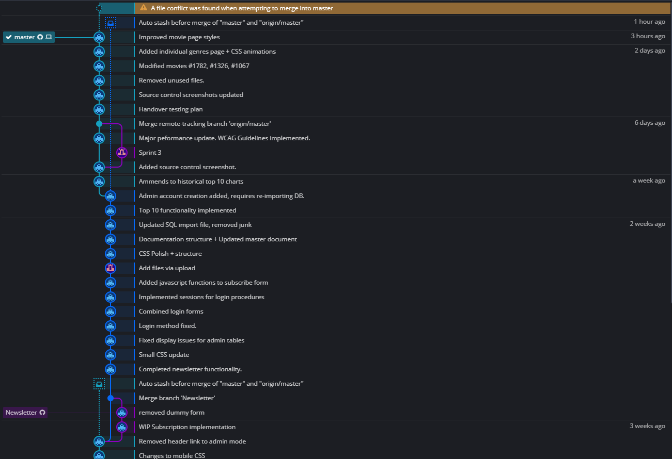

### Final Test Plan

### In Scope

The following items will be included during the testing phase:

* WCAG has implemented.
  + Perceivable
  + Operable
  + Understandable
  + Robust

### Out of Scope

Anything NOT outlined in the above scope section will NOT be tested.

### Roles and Responsibilities

### Scrum Master:

The current scrum master is Ben Royans

#### Responsibilities

* Implementing WCAG
* Fixing Bugs / Issues
* Documentation

### Developers

The current developers are Catherine Burns and Jai Ananda.

#### Responsibilities

* Programming
* Software Review Report
* Software Testing Plan

### Business Requirements

### Business Requirement Identifcation

The below table defines the business requirements for the current sprint.

|  |  |
| --- | --- |
| **Code** | **Requirement Description** |
| BR1 | Website is perceivable. |
| BR2 | Website is operable. |
| BR3 | Website is understandable. |
| BR4 | Website is robust. |

### Requirements Traceability Matrix

Below is the requirements traceability matrix outlining the cases responsible for the testing of the individual business requirements.

|  |  |  |  |
| --- | --- | --- | --- |
| **Business Requirement** | **Test Case #** | **Defects** | **Status** |
| BR1 | 1 – 4 | - | Satisfied |
| BR2 | 5 – 8 | - | Satisfied |
| BR3 | 9 - 11 | - | Satisfied |
| BR4 | 3, 4, 12 | - | Satisfied |

## Test Cases

### Test Case Results Table

|  |  |  |  |  |
| --- | --- | --- | --- | --- |
| **#** | **Requirement** | **Guideline** | **Page Comment** | **Success** |
| 1 | Perceivable | Provide text alternatives for any non-text content so that it can be changed into other forms people need, such as large print, braille, speech, symbols or simpler language. | Alternative text is provided with every displayed image. | PASS |
| 2 | Time-based media: Provide alternatives for time-based media. | Alternative provided for background videos. | PASS |
| 3 | Create content that can be presented in different ways (for example simpler layout) without losing information or structure | All pages uses a hybrid of adaptive and responsive designs. | PASS |
| 4 | Make it easier for users to see and hear content including separating foreground from background. | Stylesheets have been used to conform to a uniform style. The pages headings have been styled to contrast from normal text content and images.  Background includes a semi-opaque filter panel reducing the contrast of the background video against the foreground content. | PASS |
| 5 | Operable | Make all functionality available from a keyboard. | Website is navigatable through keyboard use only. | PASS |
| 6 | Provide users enough time to read and use content. | Error/Warning messages are kept short and to the point, and displayed for 5 seconds. All other text is not time-based. | PASS |
| 7 | Do not design content in a way that is known to cause seizures. | All content has been designed to avoid repetitive, flashing and high contrasting imagery. | PASS |
| 8 | Provide ways to help users navigate, find content, and determine where they are. | Each page is labelled with a vertical text label indicating which page the user is currently on.  The menu follows standard modern menu conventions, making it easy to find and use. | PASS |
| 9 | Understandable | Make text content readable and understandable. | All text is sized appropriately, with a legible font and written in a coherent manner. | PASS |
| 10 | Make web pages appear and operate in predictable ways. | The website operates in predictable ways with expected behaviour.  Navigation and other clickable links are demonstrated to the user with unqiue stylings. | PASS |
| 11 | Help users avoid and correct mistakes. | Error trapping and warning messages are provided to the user during processes which could involve an error or un-expected outcome. | PASS |
| 12 | Robust | Maximize compatibility with current and future user agents, including assistive technologies. | Each webpage uses adaptive and responsive design elements to ensure it will perform as intended on small devices (such as Apple Watch 400x400px) as well as large devices (scaling upwards of 1920x1080px). | PASS |

### Test Case Screenshots

|  |  |
| --- | --- |
| **#** | **Screenshot** |
| 1 |  |
| 2 |  |
| 3 |  |
| 4 |  |
| 5 | No screenshot available. |
| 6 |  |
| 7 | No screenshot available. |
| 8 |  |
| 9 |  |
| 10 |  |
| 11 |  |
| 12 |  |